World Cup 2014 in Brazil – Worship Service 6

This liturgy doesn’t contain Eucharist

Songs are suggested in the liturgy, however they may be replaced by other songs that are better known by local communities.

At this liturgy, the words in bold and italics are said by the whole community.

Prelude

Words of Welcome

Welcome to this worship service that, in the context of the World Cup in Brazil, we celebrate in the name of God, welcoming host, in the name of the Son, inclusive tenderness, in the name of the Spirit, who sets the table free. Amen.

The theme chosen for this Sunday comes from Psalm chapter 100:4 “Enter his gates with thanksgiving,
and his courts with praise.
Give thanks to him, bless his name.”

Greeting

Come, for everything is ready!
You are an inviting God.
Fish cooked with fresh tomato sauce.
You are an inviting God.
Feijoada, bar-b-qued ribs, green salad.
You are an inviting God.
Mangos, papayas, pineapples and pears.
You are an inviting God.
Work which sustains and satisfies!
You are an inviting God.
Friendships which endure.
You are an inviting God.
Equality and respect in midst of diversity.
You are an inviting God.
You receive all, include all, love all.
You are an inviting God.
At your table all sit and eat what is good.
You are an inviting God.
At your gates, all are welcome.
You are an inviting God.

Song:

Confession of Sins

Call to Confession:

As the gates of the stadiums open to welcome fans, the gates of God’s house are open to us. As juicy food is cooked to prepare a big feast, God sets her table to receive us. However, the invitation is not always accepted. Food goes cold, drinks become warm, and nobody enters the gates.
Where are the guests?
Are they on a business trip? Are they taking care of their families? Are they at the university? Perhaps watching the World Cup matches?
Are we amongst those guests who refuse the invitation?

Silence

Prayer of Confession

Let us pray:
Welcoming God,
Everything is ready, but we are not.
The invitation is clear
but we do not hear your voice through the din of our own concerns.
Forgive us.
Your love opens doors, but we go about our business and pass them by.
When we do not accept your embrace, and end up refusing to embrace others,
Forgive us.
By not entering your gates, we often close ours and lock them tight.
By declining the invitation to your feast, we end up not feasting together.
Forgive us

Song: Do fundo da angústia

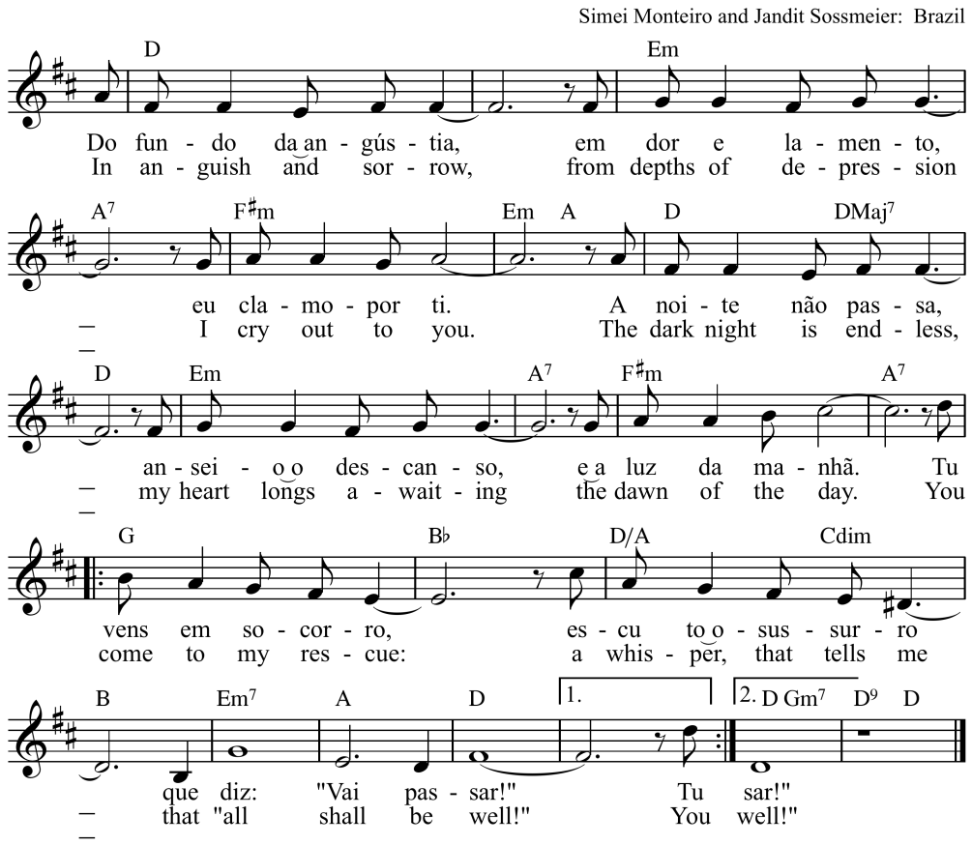

Proclamation of forgiveness of sins

Ho, everyone who thirsts, come to the waters! And you who have no money, come, buy and eat! Come, buy wine and milk without money and without price. Why do you spend your money for that which is not bread and your labor for that which does not satisfy? Listen carefully to me and eat what is good and delight yourselves in rich food (Isaiah 55:1-3a)

Sisters and brothers, in Christ our sins are forgiven and we are welcome back into the gates of God’s love. Amen.
Song: Gloria a Dios
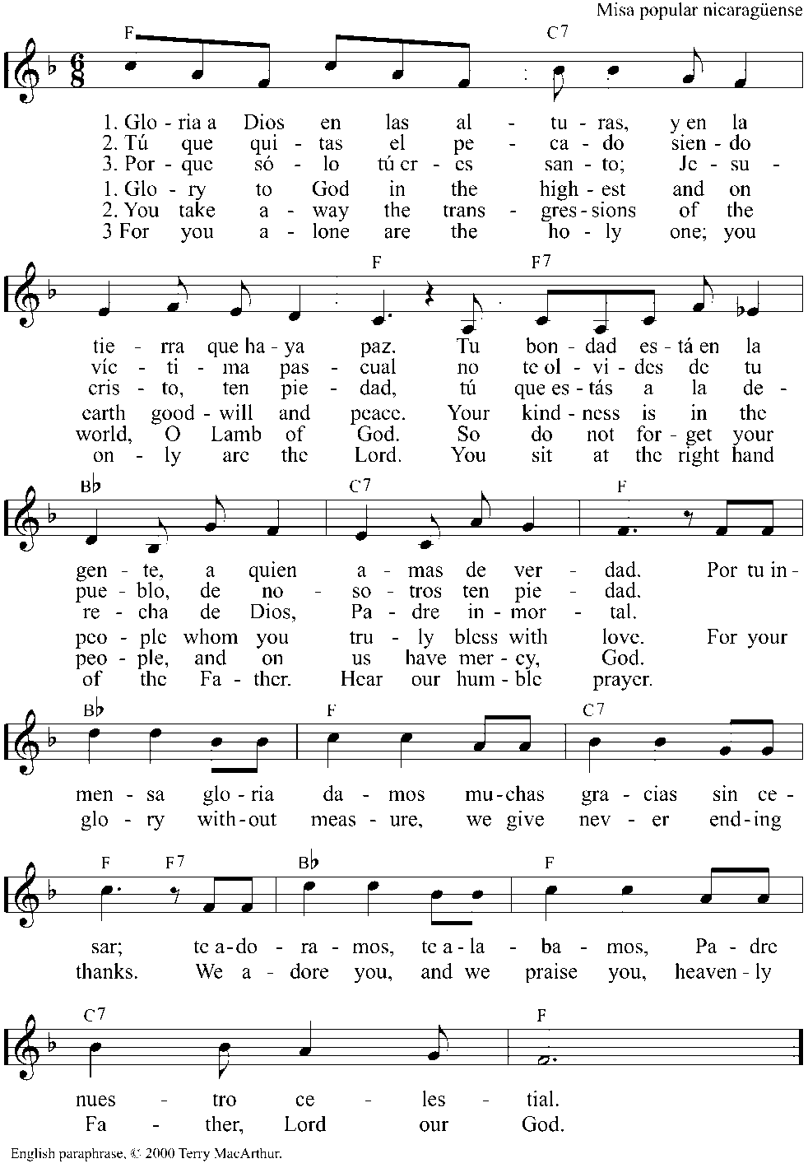

Prayer of the Day
The Lord be with you.
And also with you.

God, opening your gates, preparing a feast which we cannot refuse,
as football fans euphorically enter the gates of the stadiums, we enter your house to enjoy your feast. Help us learn from you to host without prejudice, without fear of our guests and the changes they might bring to our lives. By welcoming others we create an opportunity for meaningful encounters.
May we learn how to host, in our hearts, those people who normally would not sit at our table, would not be invited to our feast. In Jesus name we pray. Amen.

Liturgy of the Word

Old Testament Reading Isaiah 25:6-9

Song: Aleluia

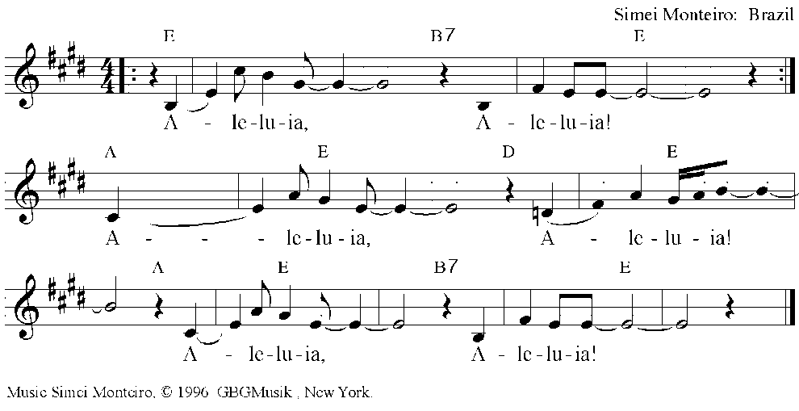
Gospel reading Luke 14:16-24

Then Jesus said to him, ‘Someone gave a great dinner and invited many. At the time for the dinner he sent his slave to say to those who had been invited, “Come; for everything is ready now.” But they all alike began to make excuses. The first said to him, “I have bought a piece of land, and I must go out and see it; please accept my apologies.” Another said, “I have bought five yoke of oxen, and I am going to try them out; please accept my apologies.” Another said, “I have just been married, and therefore I cannot come.” So the slave returned and reported this to his master. Then the owner of the house became angry and said to his slave, “Go out at once into the streets and lanes of the town and bring in the poor, the crippled, the blind, and the lame.” And the slave said, “Sir, what you ordered has been done, and there is still room.” Then the master said to the slave, “Go out into the roads and lanes, and compel people to come in, so that my house may be filled. For I tell you, none of those who were invited will taste my dinner.” ’

Sermon

Song: Venham Celebremos

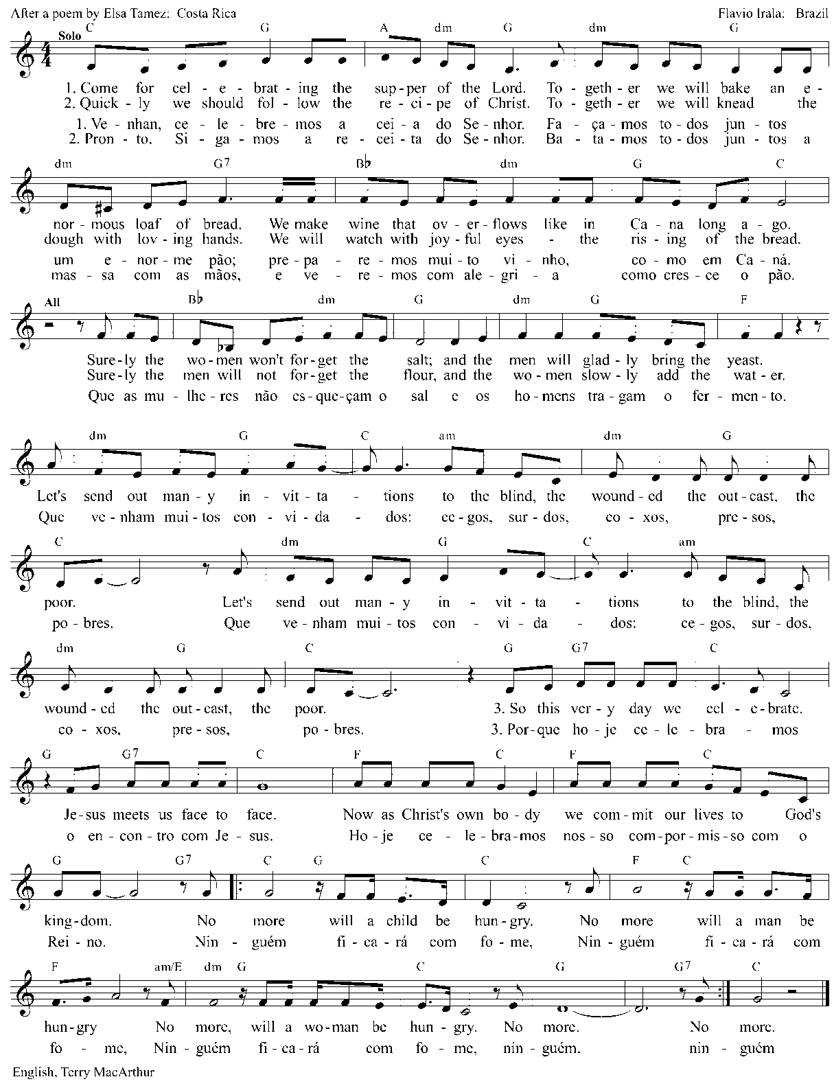

The Apostles’ Creed

I believe in God, the Father almighty,
creator of heaven and earth.

I believe in Jesus Christ, his only Son, our Lord.
He was conceived by the power of the Holy Spirit and born of the virgin Mary.

He suffered under Pontius Pilate, was crucified, died, and was buried.
He descended into hell.
On the third day he rose again.
He ascended into heaven and is seated at the right hand of the Father.
He will come again to judge the living and the dead.

I believe in the Holy Spirit, the holy catholic Church, the communion of saints,
the forgiveness of sins, the resurrection of the body, and the life everlasting. Amen

Prayers

Let us pray:

God, opening your gates, preparing a feast which we cannot refuse,
We pray for those for whom doors are not easily open. Those who do not fit the profile established by our societies, our churches, our circles. Those who are discriminated against due to their origin, race, language, gender, sexuality, way of dressing, speaking, acting, their choices. Help us to learn from Jesus, who knew no discrimination against anybody, but who was all accepting, all inclusive.

May we sit at your table and enter through your gates.

We pray for those who are suffering, for those who are ill. We remember…
We also remember the unemployed, the hungry, the poor. Embrace tenderly those who are most vulnerable in our midst, giving them comfort through the assurance that they are loved by you..

May we sit at your table and enter through your gates.

We give you thanks for the beauty of the World Cup in Brazil and for the capacity of the country to provide efficient structure so that the event can happen in peace. We rejoice for the fact that Brazilian people are welcoming and for the joy they are living at this moment.

May we sit at your table and enter through your gates.

Inspire us to be affable hosts to all. Teach us to not refuse invitations, mainly those that have the potential to bring about joy and to cheer us up. Push us from criticism toward a more constructive attitude capable of creating l friendship and love.

May we sit at your table and enter through your gates.

We pray in the name of Jesus Christ who taught us to pray saying:

Our Father

Our Father in heaven
hallowed be your name,
your Kingdom come,
your will be done,
on earth as in heaven.
Forgive our sins
as we forgive those
who sin against us.
Save us from the time of trial
And deliver us from evil.
For the kingdom, the power,
and the glory are yours,
now and forever. Amen

Benediction

Bless us God, welcoming host,
Bless us Christ, inclusiveness made flesh,
Bless us Spirit, inviting wind that blows free and open

Song: Nzamuranza

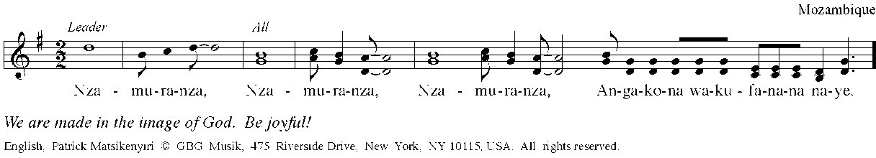

Postlude

Liturgy written by Pastor Lusmarina Campos Garcia, Evangelical Church of Lutheran Confession in Brazil. The prayer of confession was taken from the LWF 11th Assembly worship service, Day 5

