

The World Cup 2014 Brazil

Worship service 5

This liturgy was written by P. Matthias Tolsdorf

(M. Tolsdorf is pastor at the Evangelical Lutheran Church in Germany working at the Evangelical Church of Lutheran Confession in Brazil)

(This liturgy doesn`t contain Eucharist. Songs are suggested at the liturgy, however they may be replaced by other songs better known by local communities. Two songs composed for the World Cup period, Kyrie and Aleluia, as well as Credo can be found at Portal Luteranos*. During the Kyrie, a few objects will be used, therefore, they need to be arranged beforehand. It is suggested that a previous selection is done regarding the prayers of confession. At this liturgy, the words in bold and italics are said by the whole community.)

Prelude

Words of Welcome

I greet you at the beginning of this worship service asking: what brought us here? Perhaps our passion for football? Our interest in the World Cup? Or the fact that we miss God? Our reasons may vary for we are different people; we have different characters, desires, opinions, but before God we are one people, one family, and as such, we are to work for unity and solidarity in order to reveal God’s unifying love. Psalm 133:1 speaks about unity: “How very good and pleasant it is when kindred live together in unity!”

During these days, fans all over the world gather to watch the matches and to cheer for their teams. In Brazil the international community gathers as well. Besides the diversity of having people from all over the world, Brazil itself is a diverse country considering its ethnicities, cultures, origins of the population who came from Africa, Asia, Europe. All this variety becomes even more visible during this period as it brings about the opportunity of encountering others. Therefore, as Christian community we gather within the spirit of the World Cup, celebrating the opportunities of encounters and the embrace of God´s love that moves us towards truly communion.

Trinitarian Greeting

God, source of life,
Open your wings to protect us;
Lighten up your fire to enliven us;
May your gentle wind propel us for working with you;
May your strong wind renew the whole of creation.
In Jesus Christ, who lives with you and the Holy Spirit from eternity to eternity.
Amen.

Song: Gather us in

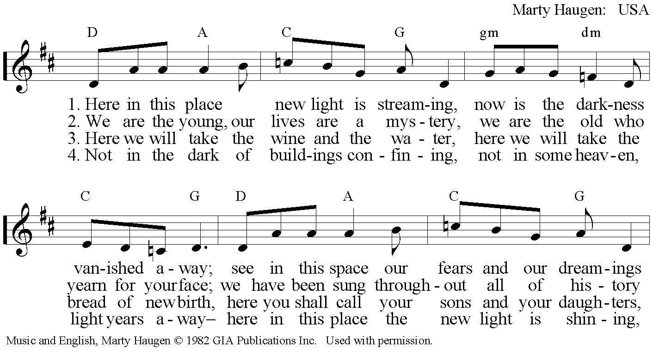
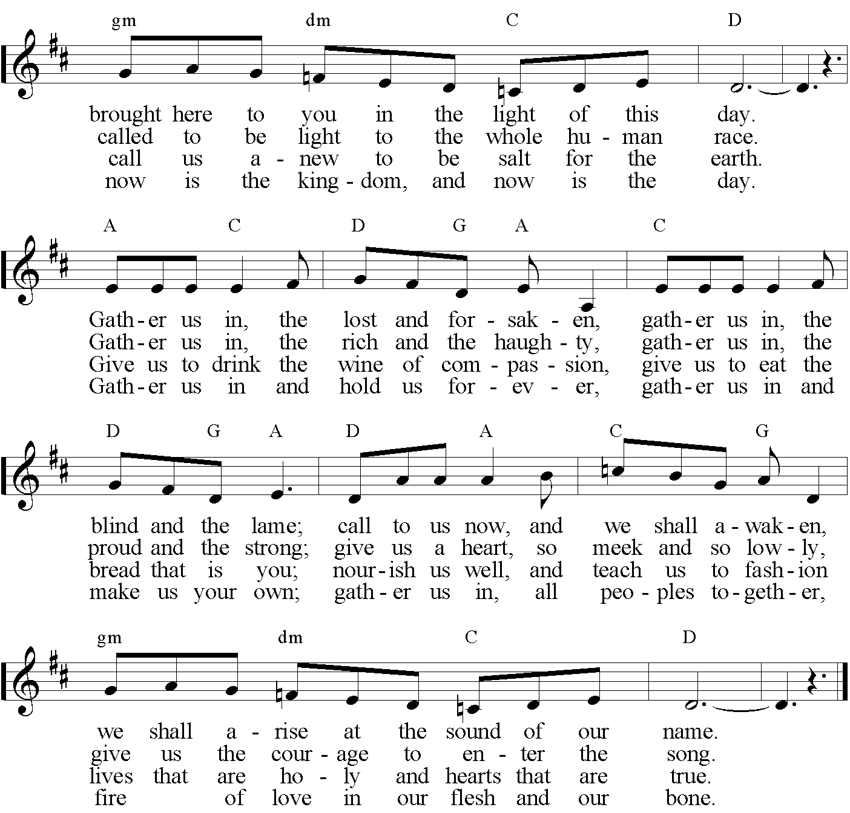

Prayer for the sorrows of the world

We pray to God, who feasts with us when we are glad, and cries with us when we are saddened. Before each prayer, a symbol connected to the words will be brought in. As we name the “sorrows of the world” the community responds: Have mercy on us, Oh God!

L. (a football ball is brought in): We pray for Brazil where social gap and corruption still exist in spite of enormous development in the last decade. And so we ask:
Have mercy on us, oh God.
L. (a hammer is brought in): We pray for the unemployed of the world and those who are lacking joy and hope and who may see no sense in life any longer. And so we ask:
Have mercy on us, oh God.
L. (a piece of black canvas is brought in): We pray for the homeless, the victims of catastrophes, the refugees, the victims of war, persecution and violence. And so we ask:
Have mercy on us, oh God.
L. (a red card is brought in): We pray for the victims of unfair and violent games, either in political, cultural, sportive or social sense. And so we ask:
Have mercy on us, oh God.
L. (a bottle of water in brought in): We pray for those who are thirsty and hungry, who have no access to clean water or free from pesticides food. And so we ask:
Have mercy on us, oh God.
L. (a broken pot is brought in): We pray for ethnicities that are persecuted, marginalized and decimated. And so we ask:
Have mercy on us, oh God.
L. (a newspaper reporting violence or bad behavior during the matches of the World Cup is brought in): We ask for the victims of racism, the victims of violent behaviors, those who suffer intolerance and fanaticism. And so we ask:
Have mercy on us, oh God.
L. (a syringe is brought in): We pray for those who suffer with drug addiction, drug trafficking, and crimes related to drug consumption. And so we ask:
Have mercy on us, oh God.
L. (a money bill is brought in): We pray for those who are attracted, mislead, or kidnapped by the human trafficking system in Brazil and in the whole world. And so we ask:
Have mercy on us, oh God.
L. (a plant planted is brought in): We pray for the planet and its biodiversity; we pray for the species under risk to be extinct. And so we ask:
Have mercy on us, oh God.

Song: Kyrie

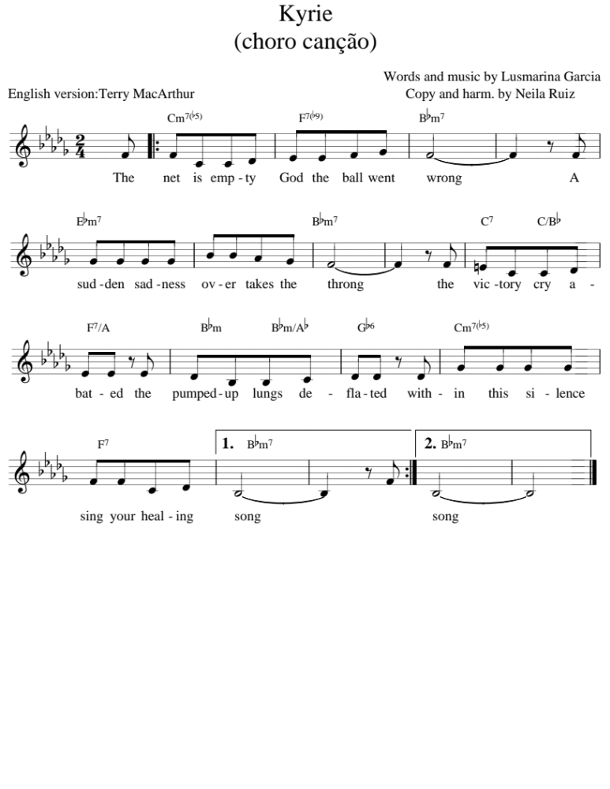Forgiveness of sins
God hears our prayers and never abandons us. God’s love and fidelity give wings to our hope e our joy. We praise the present and forgiving God singing Gloria!

Song: Glória

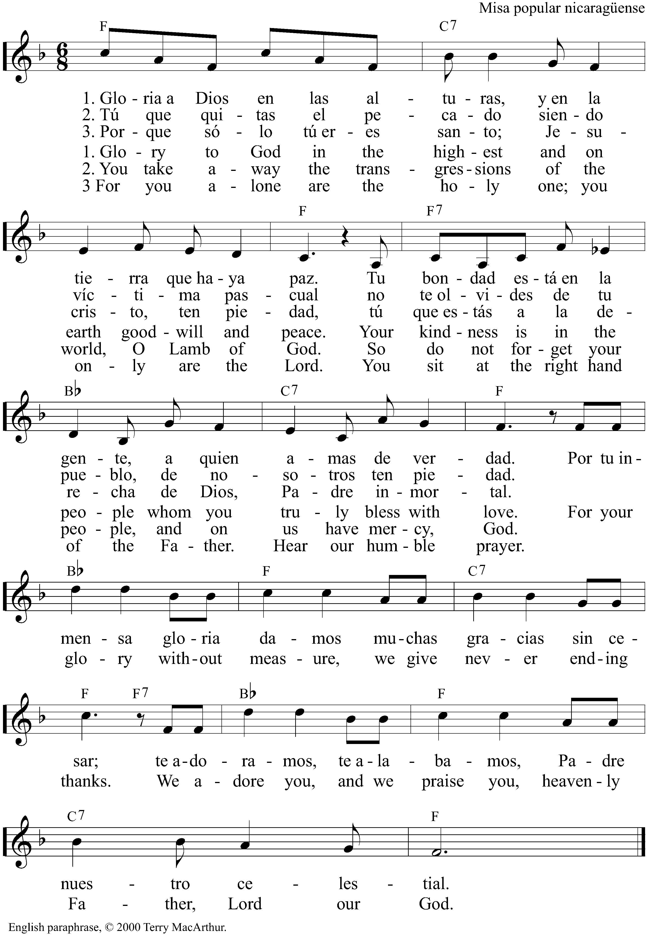

Prayer of the Day

The Lord be with you.
And also with you.

Loving God, we give you thanks for revealing your love and your will to us. As you call and accompany your people, you become close to us and unite us. In Jesus Christ birth, life and death you ensure your faithful presence to us. When calling and gathering his disciples, Jesus also called us to live in solidarity. Send your Holy Spirit upon us and transform a group of individuals into a community. In the name of Jesus Christ, your beloved son, our savior. Amen.

Epistle reading: Ephesians 4:1-6

Gospel reading: John 2:1-11

Song: Credo
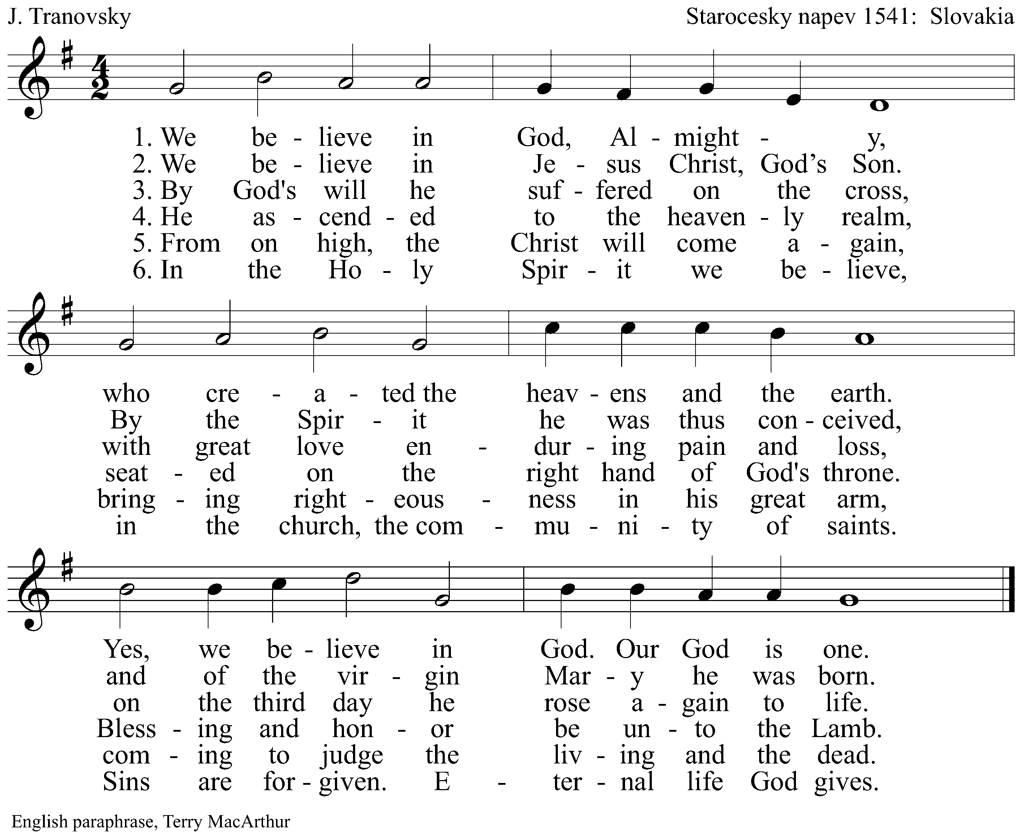

Sermon

Song: Confitemini Domino

Let us give thanks to the Lord who is good.
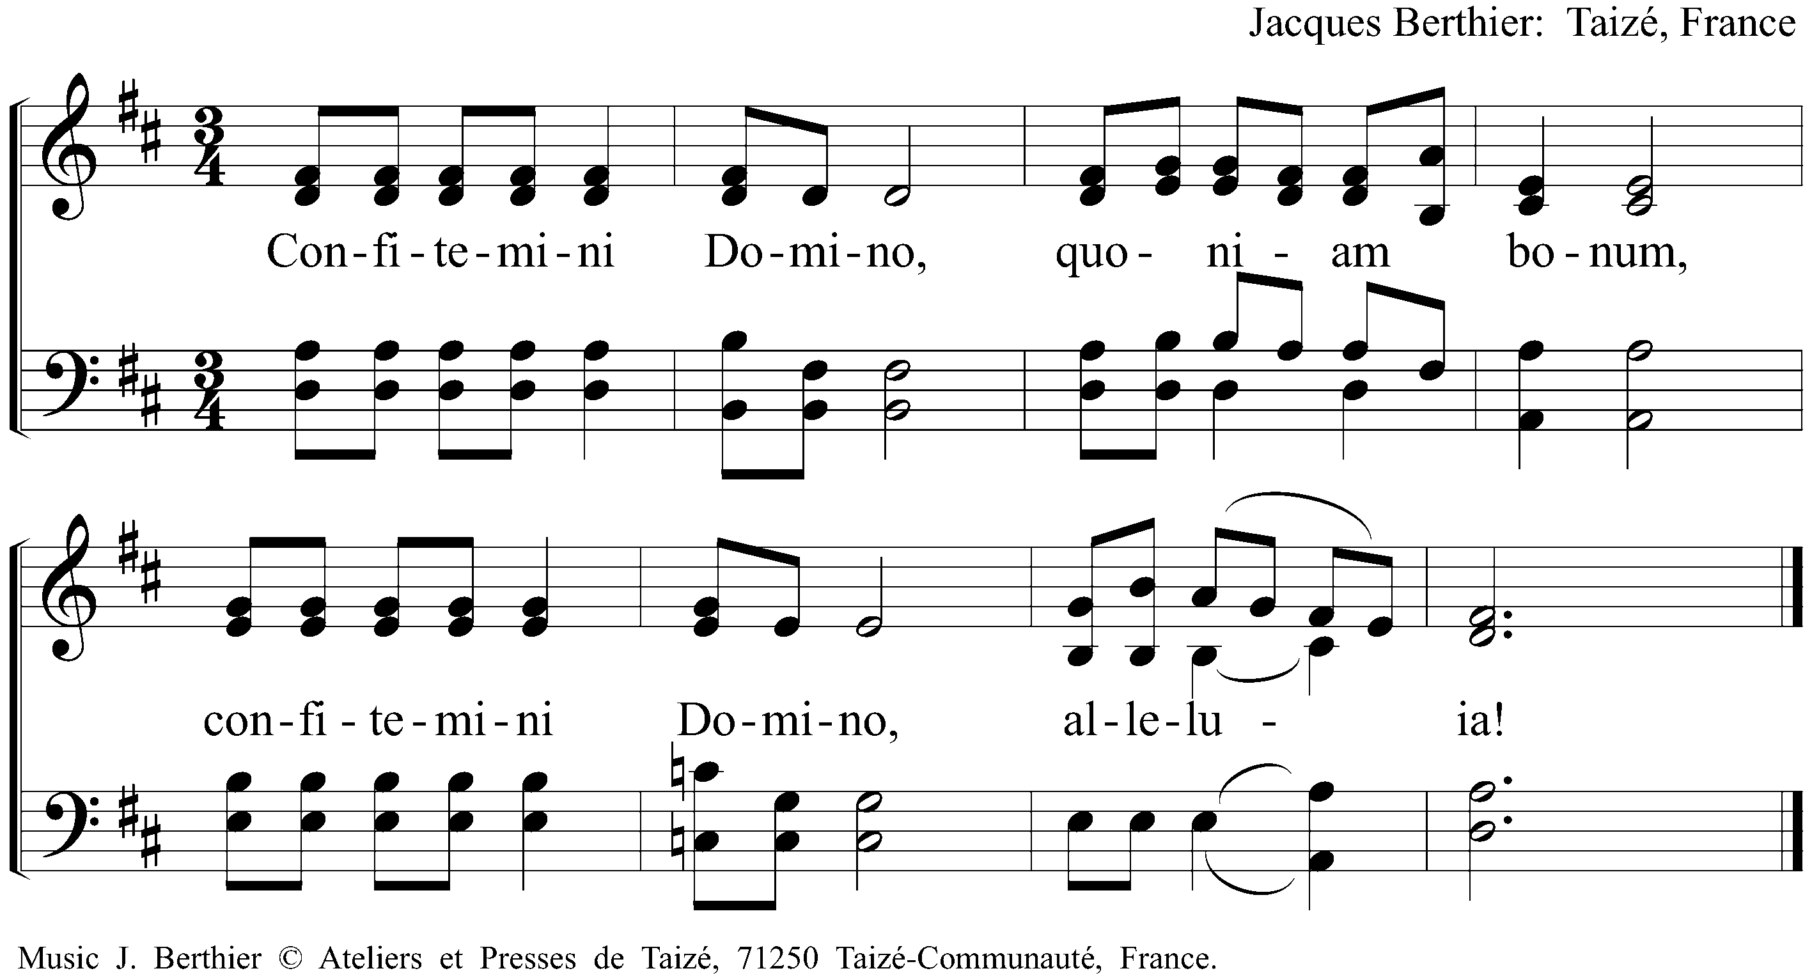

Announcements

Song: You have all my future in your hands

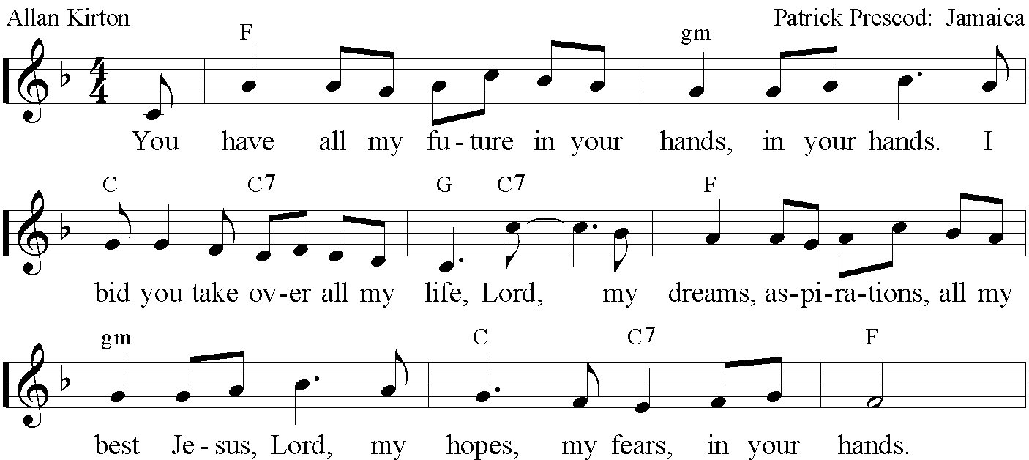
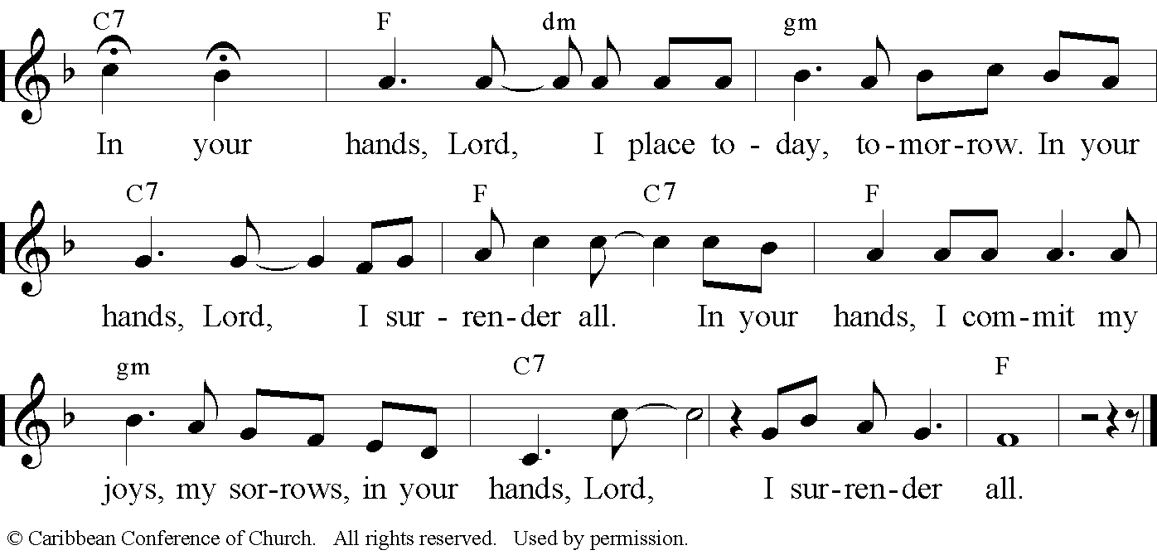

Prayer of Intercession

Loving God, creator of the world, we give you thanks for the World Cup and for the opportunities of encounters it opens and communion it inspires. Give us strength to build bridges toward those who are foreigners in our midst and strange to our way of living. Help us to invest more in solidarity. Make of us ambassadors to the reconciliation Christ operated in our lives and move us toward those who are excluded and marginalized because of ethnicity, nationality, gender and sexuality.

Send your Spirit upon us awakening joy and unity.

Loving God, send your Holy Spirit upon all who are working for the World Cup: administrators, players, coaches, doctors, volunteers, drivers, government people... May the same Spirit come upon the whole population of Brazil and of the whole world giving us all a time filled with respect, tolerance, solidarity and the sense of belonging together to the International community and the same humanity.

Send your Spirit upon us awakening joy and unity.

Loving God, capacitate players, judges, coaches to become fair model for clean and transparent game. May their public declarations be done in good and constructive language and gestures. Give us the gift of watching impressive plays, living through exciting moments, experiencing fascination as we encounter other people.

Send your Spirit upon us awakening joy and unity.

We give you thanks for all that Brazil invested in terms of infra-structure that will remain for the population of the country. We ask that the jobs that were created during these years may be relocated so workers continue employed; the solar energy collected at the stadiums that were built with capacity to collect it be distributed in a fair way and all the income be used to diminish poverty and to help the most vulnerable in Brazilian society.
Send your Spirit upon us awakening joy and unity.

We pray in the name of Jesus Christ who taught us to pray saying:

Our Father

Our Father in heaven
hallowed be your name,
your Kingdom come,
your will be done,
on earth as in heaven.
Forgive our sins
as we forgive those
who sin against us.
Save us from the time of trial
And deliver us from evil.
For the kingdom, the power,
and the glory are yours,
now and forever. Amen

Song: Aleluia

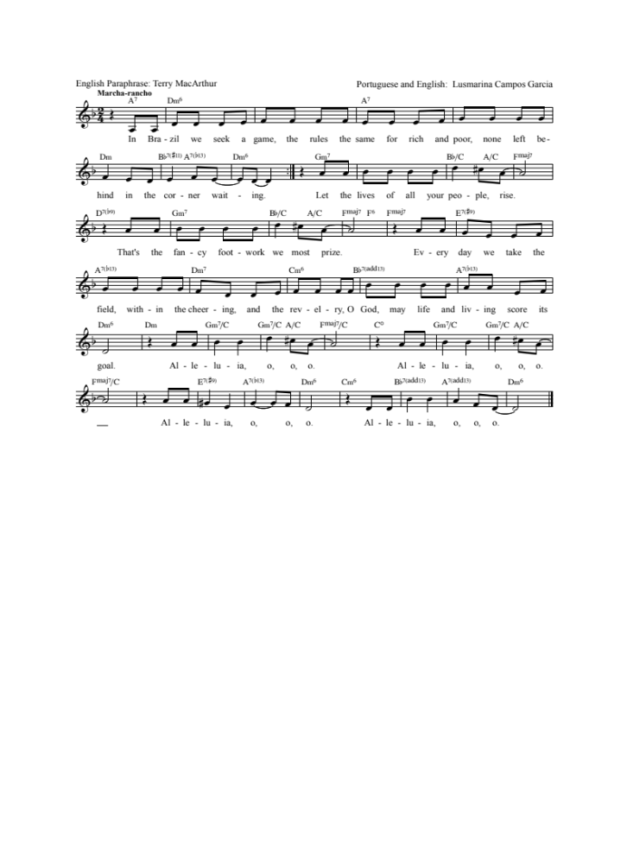
Benediction
Brazilian people use their bodies to express closeness, to dance, to express emotions in a “touching” way. That means, they are free to touch each other’s body without prejudice or malice. Each region of the country has its own rhythms and typical dances. So, either in Carnaval or football, Brazilians will dance, will express their joy and celebration through movement. Therefore, at his moment, the Benediction will be said with words-promises that touch and involve different parts of the body and different senses.

May God bless you:
Making your feet dance,
Strengthening your arms,
Opening your hands,
Making you strong, but also sensitive, to support those in need,
Caressing your ears with enchanted melodies,
Entering your nose with inspiring aromas,
Filling your eyes with smiles,
your hearts with joy,
and your mouths with a new song.
Bless you God, the Father, the Son, and the Holy Spirit.
Amen.

Song: Momento Novo

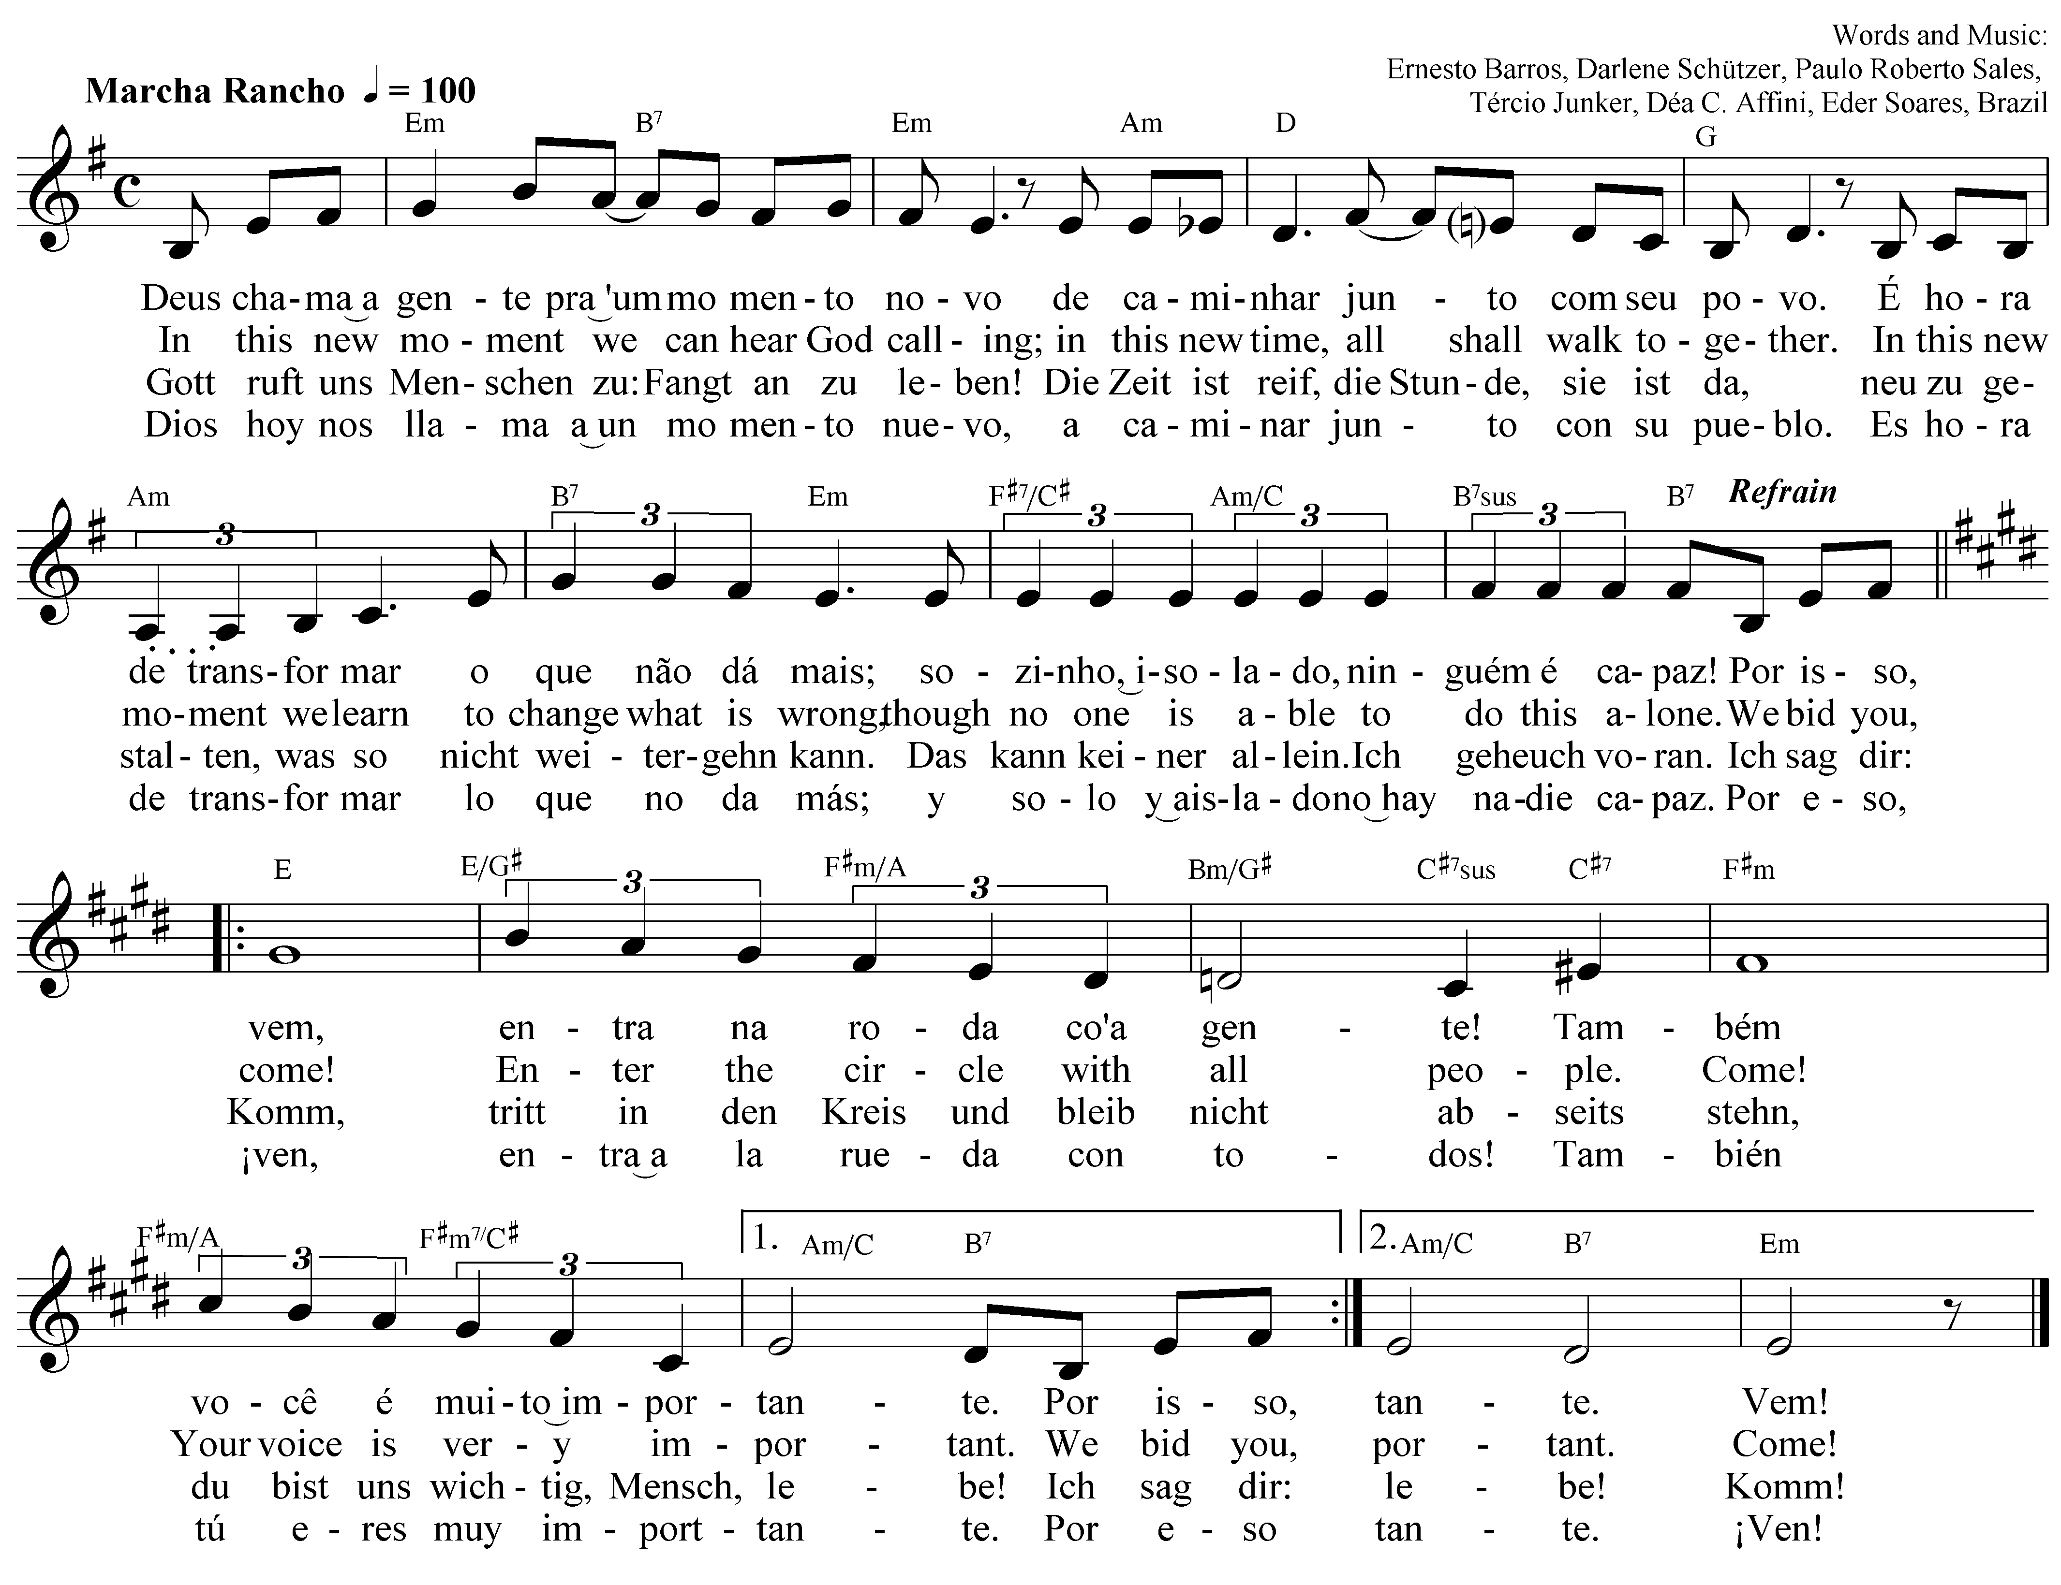

Postlude

