World Cup 2014 Brazil

Worship Service 4

This liturgy was written by P. Matthias Tolsdorf
(M. Tolsdorf is pastor at the Evangelical Lutheran Church in Germany working at the Evangelical Church of Lutheran Confession in Brazil)

(This liturgy doesn`t contain Eucharist. Songs are suggest at the liturgy, however they may be replaced by other songs better known by local communities. At this liturgy, the words in bold and italics are said by the whole community.)

Prelude

Words of Welcome

Welcome to this worship service. I would like to greet you by asking: “what are you looking for?” I don’t mean to be intrusive, but I would like us to reflect on our motivation for being here. Perhaps some of us are searching for an experience of encounter and togetherness, like when people are cheering for a team at the World Cup. Perhaps others search for a calm space away from noise and agitation. Still others might be searching for inspiration through faith. “To search for”, “motivation” and “goals” are themes at the heart of this worship service.
An event such as the World Cup helps us reflect on these themes because players and coaches are motivated to reach a big goal. Moved by the desire to get the Cup they apply all their talent and extraordinary abilities and captivate the attention of millions of people around the world as they play each match, as they win or loose. And we, their fans, have strong emotions as we follow all their plays, as we identify with them, their aims, as we are motivated by their own dedication. As we ask ourselves about our own motivation we are accompanied by the Gospel of Matthew chapter 6 verse 33 which says: “ But strive first for the kingdom of God* and his* righteousness, and all these things will be given to you as well.”

We celebrate in the name of the Triune God: the One who gives us hope, fills you with joy and peace through faith; the One who is merciful, awakening in you his faithful love and strengthening your hope through the power of the Holy Spirit. (inspired by Romans 15.13)

Praying with Psalm 98 – Song: Cantai ao Senhor

Praying for the sorrows of our world

Protests in Brazil have raised concerns about social inequality and poverty in Brazilian society. Although throughout the last decade more than ever before was accomplished, Brazilians want changes to happen even faster. For some, to participate in the World Cup is inconsistent with what is really needed in Brazil. They want more schools, hospitals, public transportation. We join our voices with those protesting in Brazil and all over the world praying for the whole of humanity who are afflicted with sorrows, for God promises to hear our cries and to accompany us.

Song: Kyrie
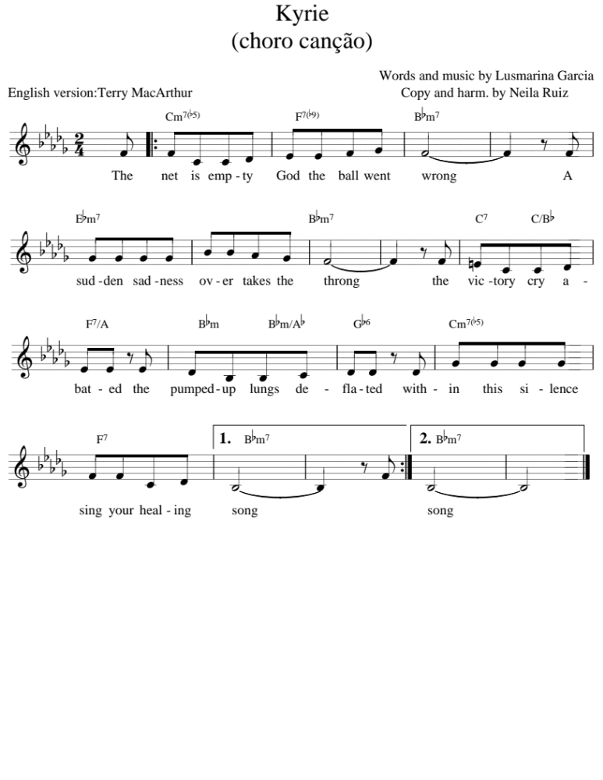

Proclamation of God’s Grace

Sisters and brothers, God hears our cries and never abandons us. God’s love and faithfulness give wings to our hopes and joys, making us fly free in God’s abundant grace. Therefore, we sing with joy.

Song: Gloria

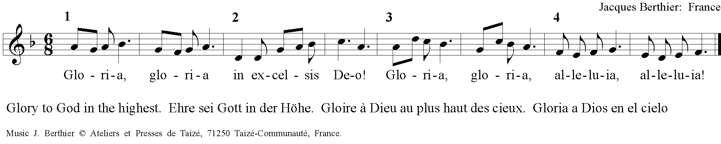

Prayer of the Day
Loving God, we give you thanks for our lives, our desires, our dreams, and for the strength you grant us to pursue all that we lack. Emotions and fantasies inspire us, motivate us and move us forward to overcome our limitations. Grant us attention and concentration at this moment so we can learn from your Word and also from the example of the football players and coaches who run without stopping to reach their goal. Help us see what are the inspirations, motivations and goals you want for us. In the name of Jesus Christ. Amen

Song: Tua palavra na vida

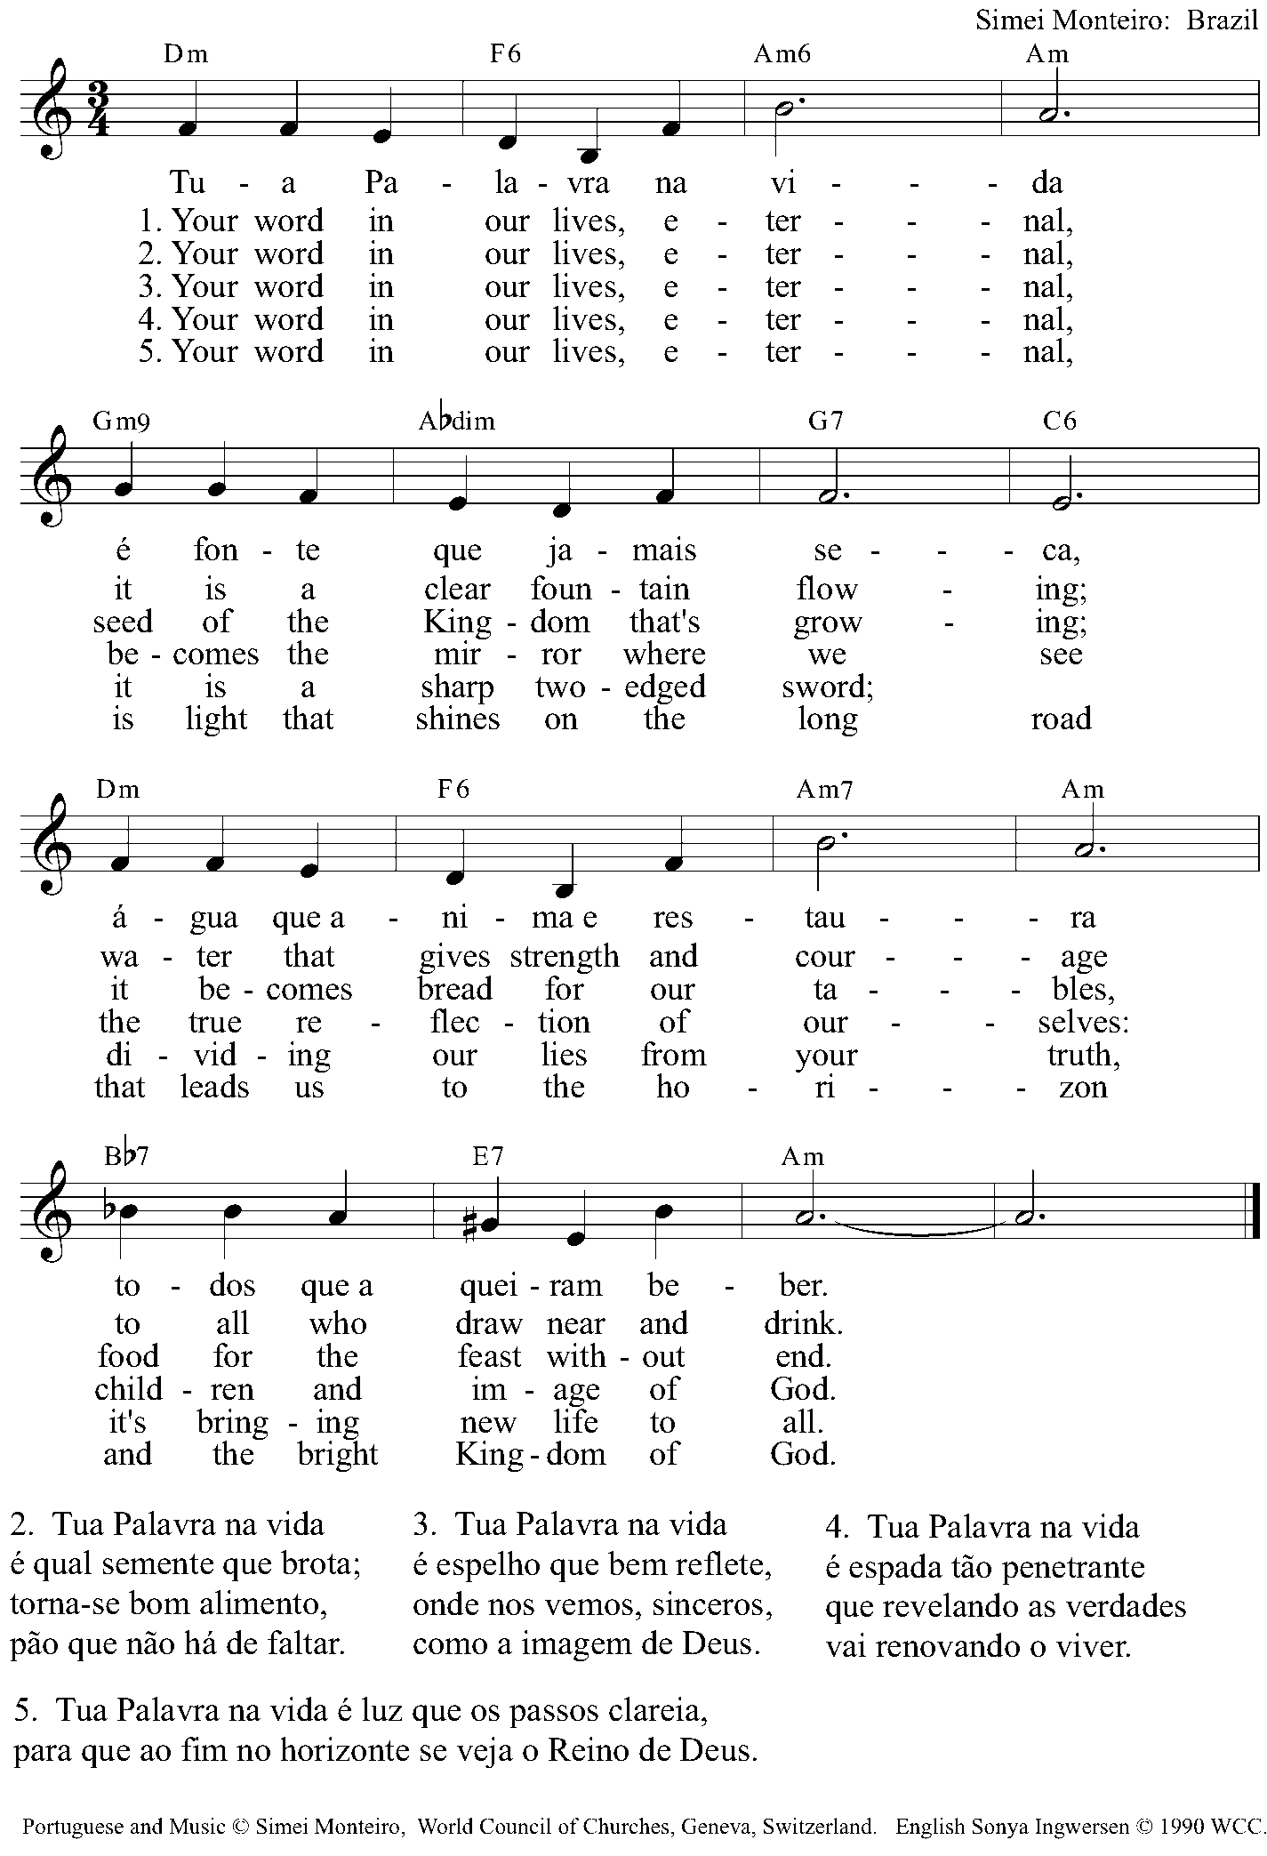

Epistle reading: Philippians 3:12-14

Gospel reading: Matthew 13:44-46

Song: We believe

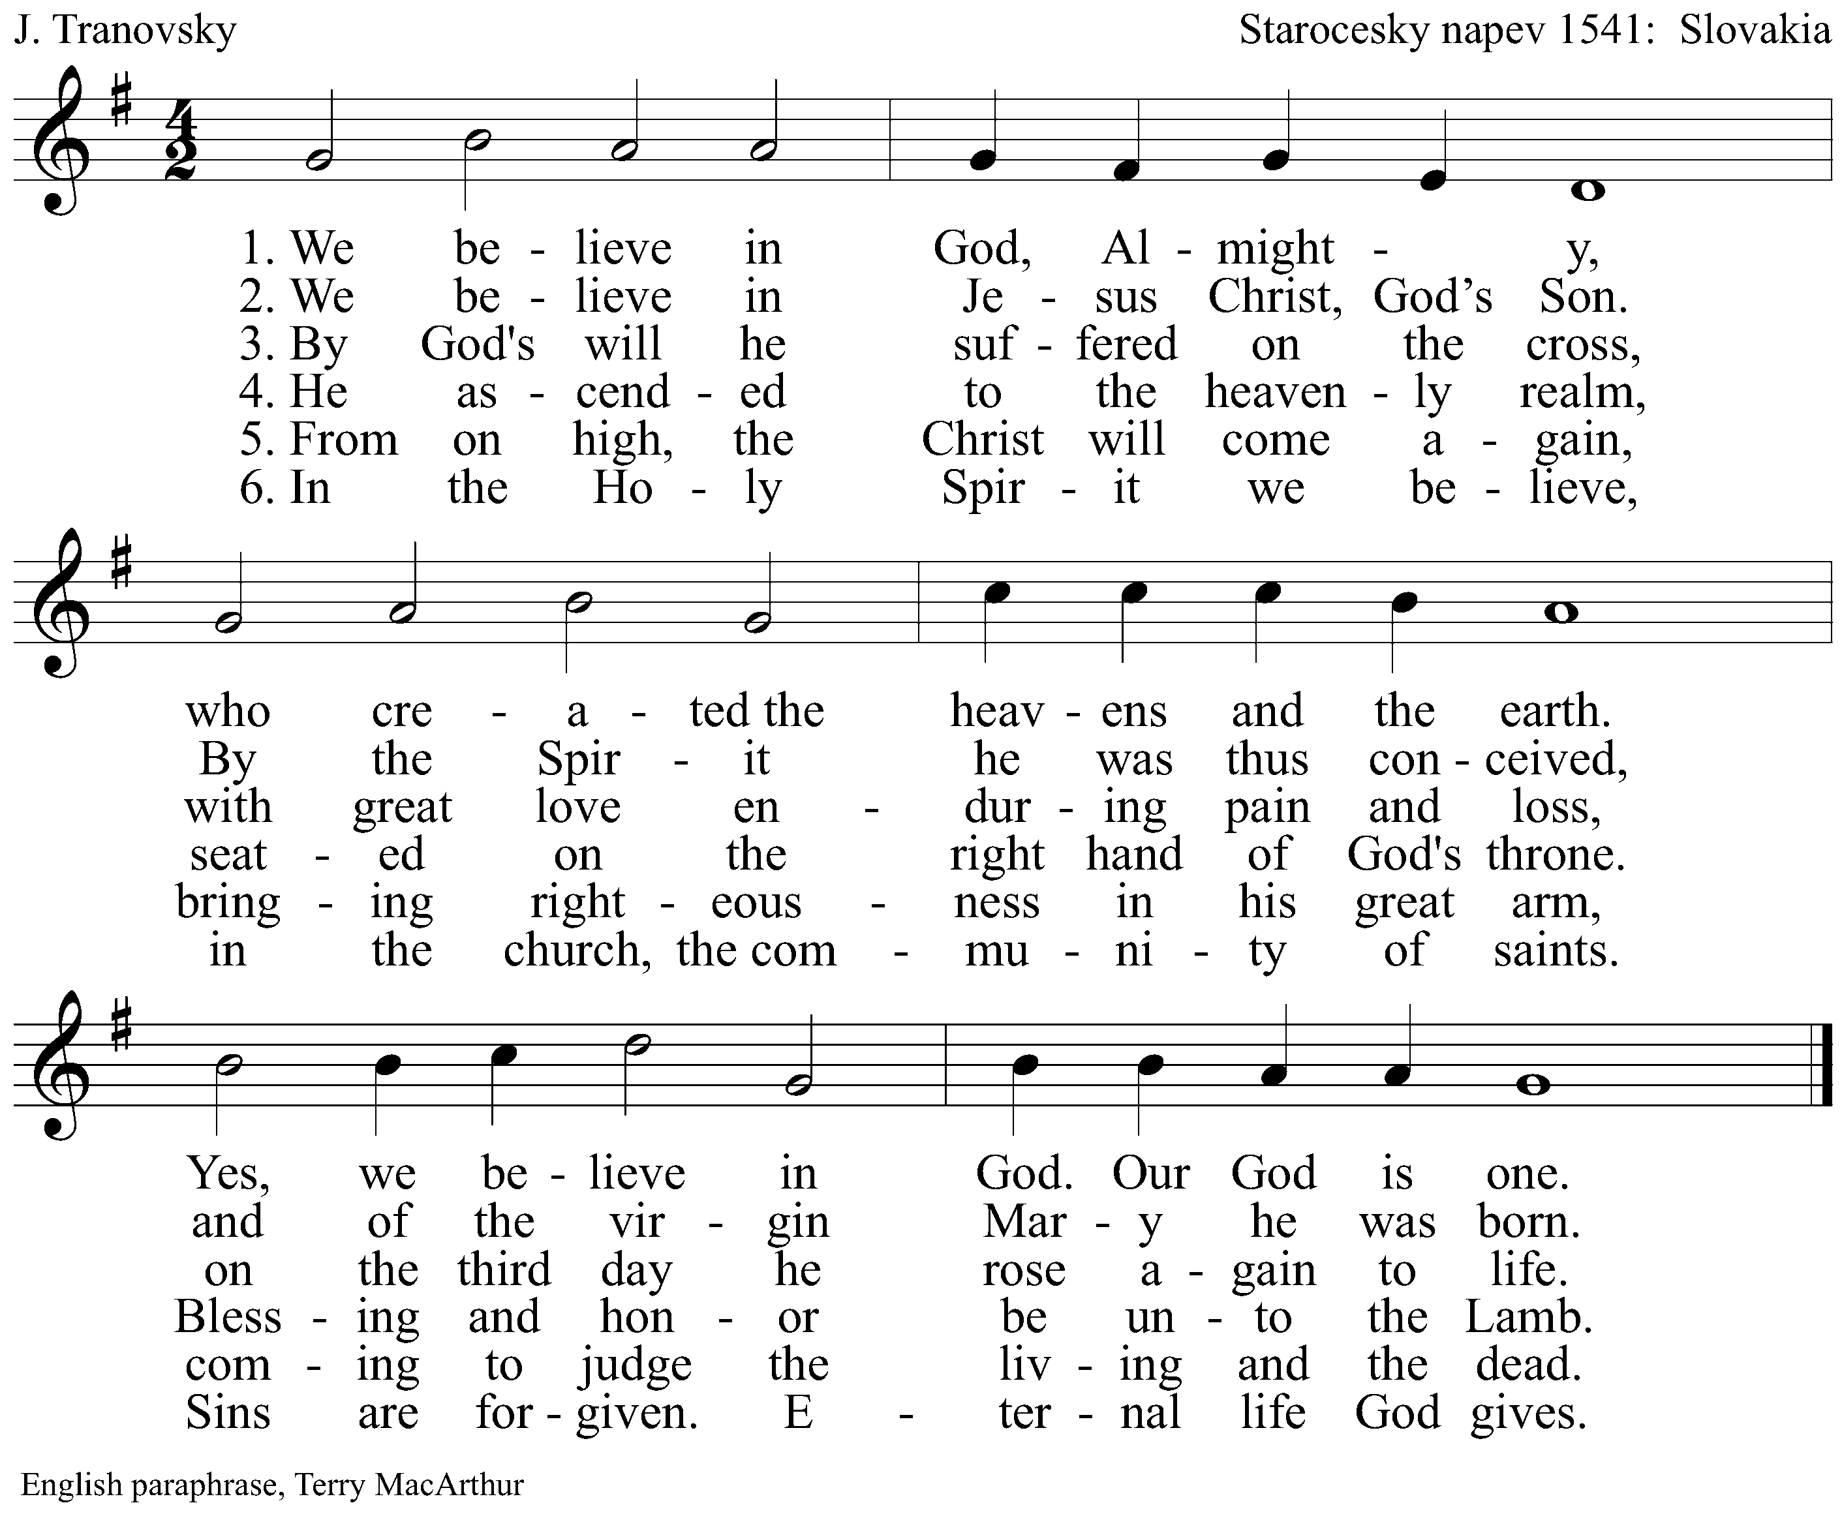

Sermon

Song : Let us with gladsome mind

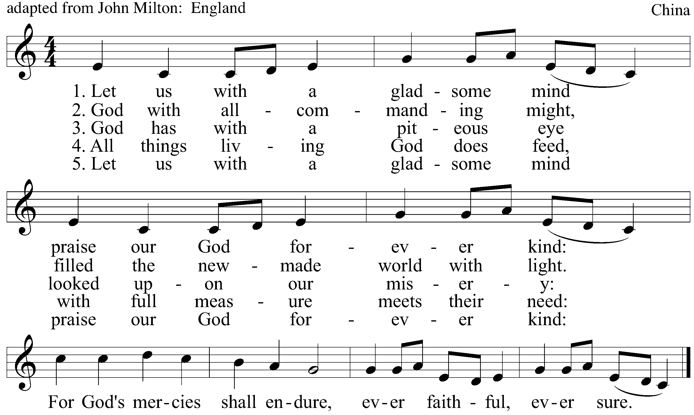

Prayer of Intercession
Loving God, creator of the whole World,
We are thankful for sports, for sports competitions, for mega-events such as the World Cup. We ask that this World Cup be used as an opportunity for feasting, for meaningful encounters amongst people of different nations, for experiencing tolerance.

Send your Spirit upon us inspiring us to joy, faith and action.

We pray for the referees, linemen, coaches, players and fans to have a positive attitude. May those who win keep from humiliating those who loose, avoiding frustration and violence. Help those who loose to be mature and set a positive example for all who watch the games throughout the world.

Send your Spirit upon us inspiring us to joy, faith and action.

We pray for Christian churches around the world. Pour joy upon all your children, so we, like football players, accomplish much and work toward our aims. Grant us renewed energy to bring about happiness and hope.

Send your Spirit upon us inspiring us to joy, faith and action.

Grant us awareness of your call to us to cultivate enjoyment, and perseverance. Help us to remember your promises, granting us salvation and eternal life; may we never loose sight of your unending mercy as we live out communion within the sphere of your Realm. Rooted in your grace may we find strength for solidarity.

Send your Spirit upon us inspiring us to joy, faith and action.

Be with the people of Brazil. May the resources used to host the World Cup return to the population and bring about sustainable development and social justice. May the profits be used to fight corruption. We pray for the police, for politicians and for civil society; may all different segments of Brazilian society be strongly committed to overcome human trafficking, forced prostitution and drug trafficking.

Send your Spirit upon us inspiring us to joy, faith and action.

In spite of social injustices, corruption and poverty, Brazilian people say that “God is Brazilian” and they live inspired by saying “hope is the last one to die”. Help them and us to understand that our hope is founded in you and our joy is born in your promises.

Send your Spirit upon us inspiring us to joy, faith and action.

We pray in the name of Jesus Christ, who taught us to pray saying:

Our Father

Our Father in heaven
hallowed be your name,
your Kingdom come,
your will be done,
on earth as in heaven.
Forgive our sins
as we forgive those
who sin against us.
Save us from the time of trial
And deliver us from evil.
For the kingdom, the power,
and the glory are yours,
now and forever. Amen

Song: Aleluia

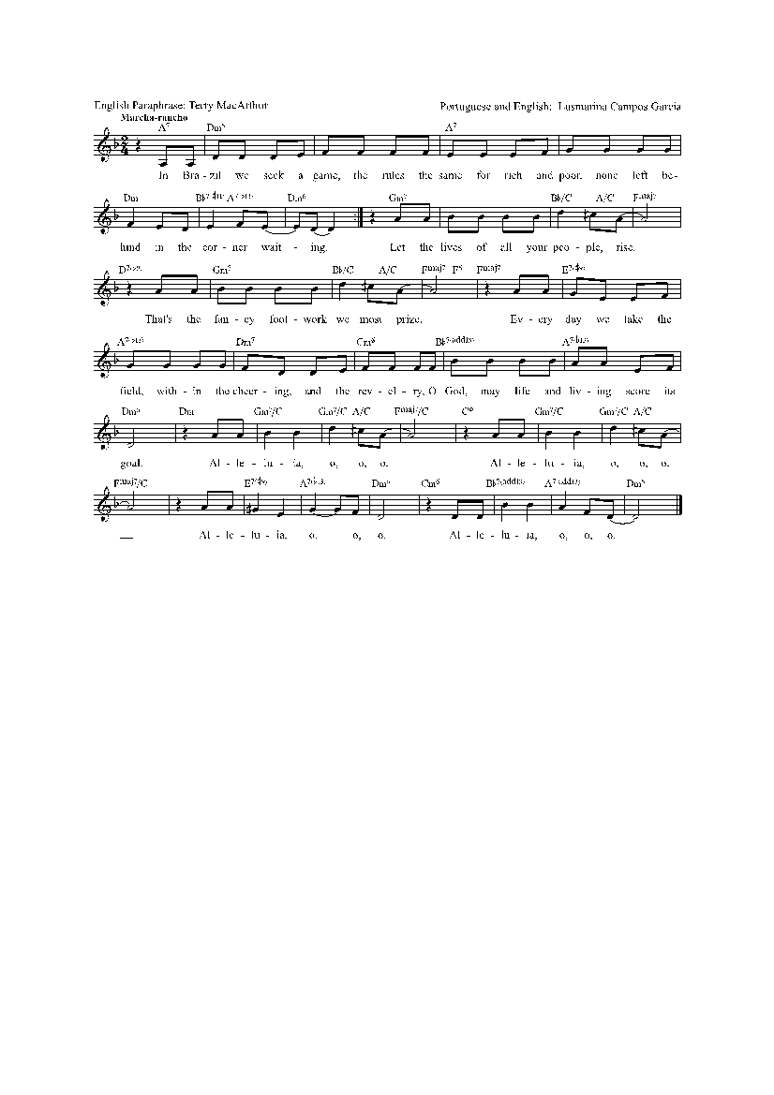

Benediction
Sports and championships have the power to divide and separate strong and weak, winners and losers. But as it is said at the Olympic Games: “The most important is to participate/to participate is everything”. We now receive God’s blessing which assures us that we belong to God; in God we are not marginalized, we are not “the ball” but we are “the players”.

May God bless you. May God’s blessing bring about trust in God’s plans for your life. You are not to be left behind or sitting on the reserve bench.
May God inspire you with ability to find the best move at each moment of your life.
May God grant you sensitivity and respect so you treat others as friends belonging to the same team.
May God grant you courage to hold up the red card when people foul against life.
May God grant you strength to search for joy which comes from true life, now and forever more.

Song: Tatanaka mamanaka sarantañani

