World Cup 2014 in Brazil – Worship Service 3

This liturgy doesn’t contain Eucharist

Songs are suggested in the liturgy, however they may be replaced by other songs that are better known by local communities.

At this liturgy, the words in bold and italics are said by the whole community.

Prelude

Words of Welcome

Welcome to this worship service that, in the context of the World Cup in Brazil, we celebrate in the name of God, Father and Mother of profound love, in the name of the Son, whose poverty set us free, in the name of the Spirit, who transforms burden into lightness. Amen.

The theme chosen for this Sunday comes from Psalm chapter 145:8-9 “The Lord is gracious and merciful, slow to anger and abounding in steadfast love. The Lord is good to all, and his compassion is over all that he has made.”.

Greeting

Throughout the city streets
flutes, charangos, drums and guitars play,
giving pace to bold steps and to dances.
A flabbergasting feast breaks forth loose
amongst fandango and samba,
forró and maracatu,
from evening to dawn.
Joy spreads throughout the air
entering houses and shops, churches and street markets.

What was heavy becomes light,
What was dull becomes sharp,
The bentstraighten up,
and the unsmiling smile again.
Life frees itself like at a football counterattack
that is built on quick moves
and impetuous bold pitches.
Life becomes light,
as if it were a skillful player
who runs unstoppably towards the goal,
fearless,
jumping,
letting himself go,
completely caught by the game.
We are also caught by your lightness, God.

Song: Lord of the dance

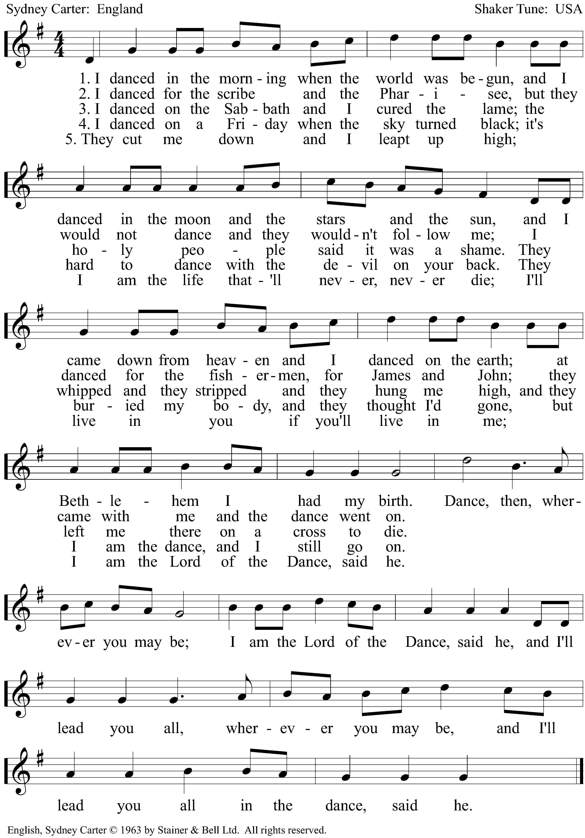

Confession of Sins

Call to Confession:

Impediment is the word we are invited to think about at this moment.
Impediments are various and diverse. We are impeded from going forward and reaching our goals due to external or internal reasons. Sometimes somebody else obstructs our way and we have to stop, like a player who suffers a foul. Sometimes it is us, ourselves, who obstruct our own way due to our habit to disagree, to be fearful, cynical, or dissatisfied. . Therefore, we confess that which impedes us.

Let us pray:

God, well placed lineman,
We confess before you that which impedes us.
When we complain more than we propose,
When we criticise more than we invest,
When we judge more than we reflect,
forgive us.
When we disqualify more than we appreciate,
When we deconstruct more than we build,
When we obstruct more than we liberate,
forgive us.
When we repeat lies,
When we reproduce negativity,
When we supplant joy.
forgive us.

Song: Search me, O God!

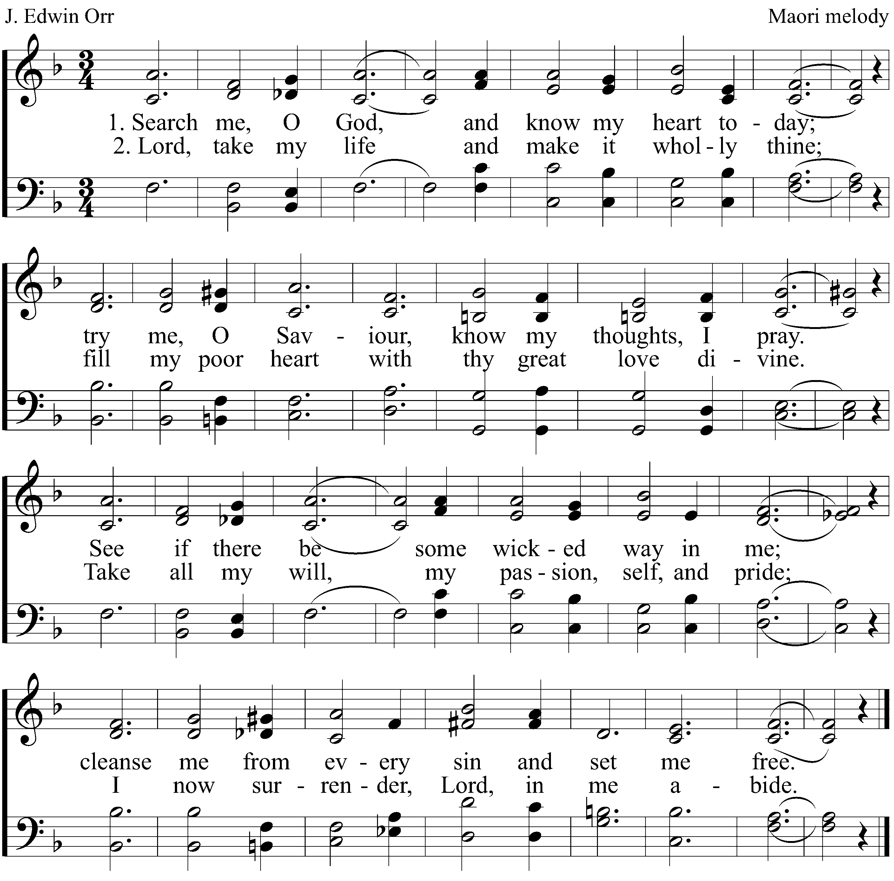

Proclamation of forgiveness of sins

“The Lord is faithful in all his words, and gracious in all his deeds.* ¹⁴ The Lord upholds all who are falling, and raises up all who are bowed down. ¹⁸ The Lord is near to all who call on him, to all who call on him in truth”. Psalm 145:13b-14,18
Sisters and brothers, in Christ our weariness becomes strength and our heavy burdens become light. Amen.
Song:
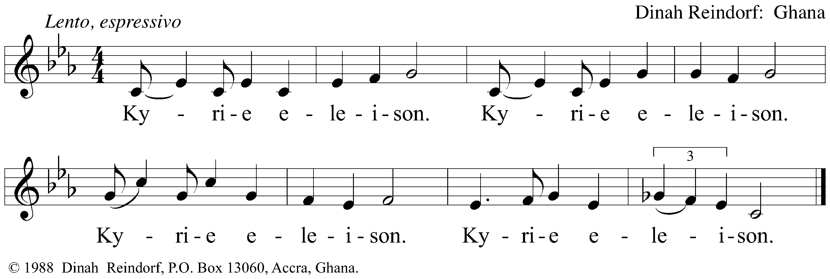
Prayer of de Day
The Lord be with you.
And also with you.

God, whose yoke is easy and whose burden is light,
it is your blowing wind that blows our yokes and burdens away.
It is your gracious love that unblocks our impediments and sets us free.
As the football players reorganize their team for a counterattack strategy,
we want to have our lives rearranged at your mercy. As they run to kick the ball into the goal, we want to run toward results that express your grace.
Convince us with your love, so embraced by it,
we jump into the logic of your simplicity,
and let ourselves go into your everlasting friendship.
In Jesus name we pray. Amen

Liturgy of the Word

Old Testament Reading Zachariah 9:9-12

Song: Aleluya

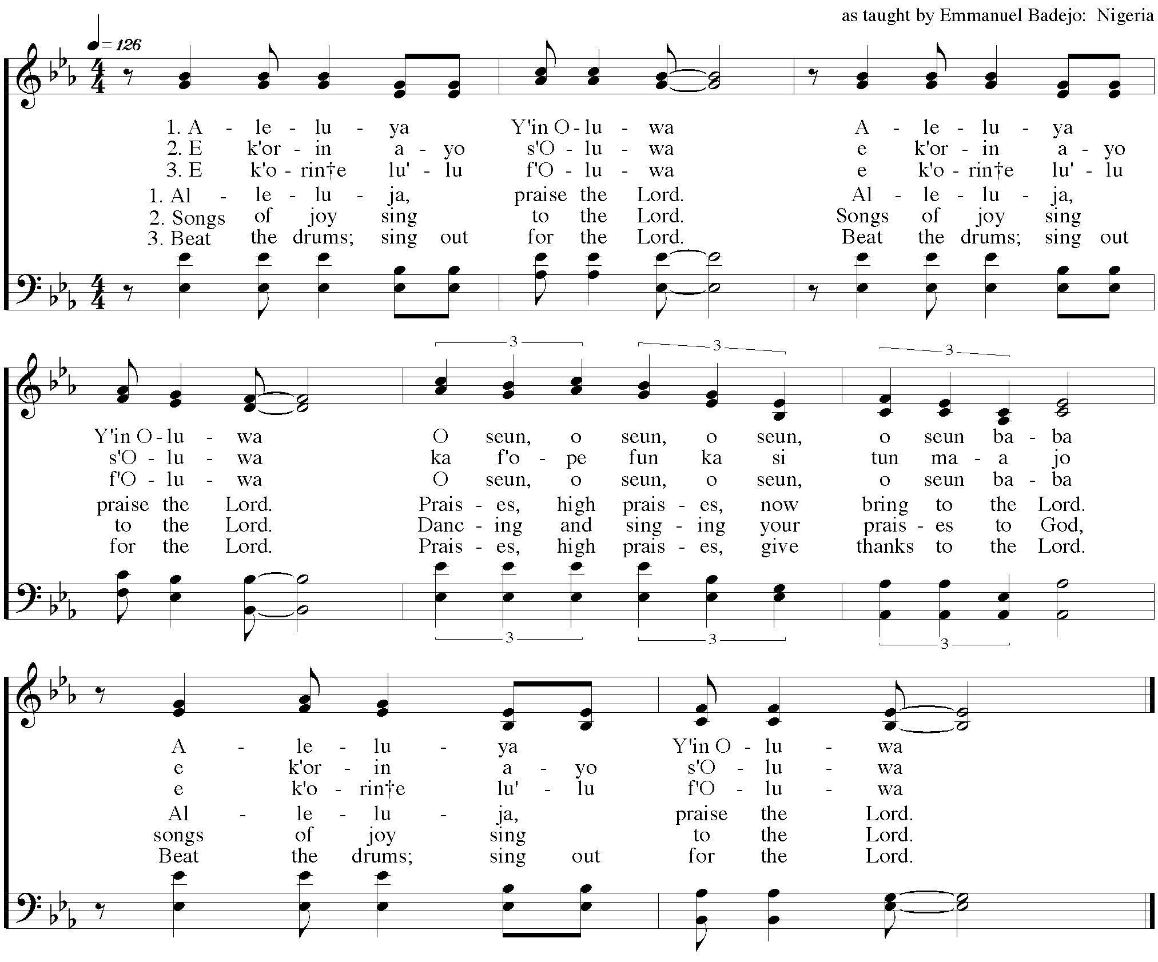
Gospel Reading Matthew 11:16-19; 25-30

Sermon

Song: I heard the voice of Jesus say

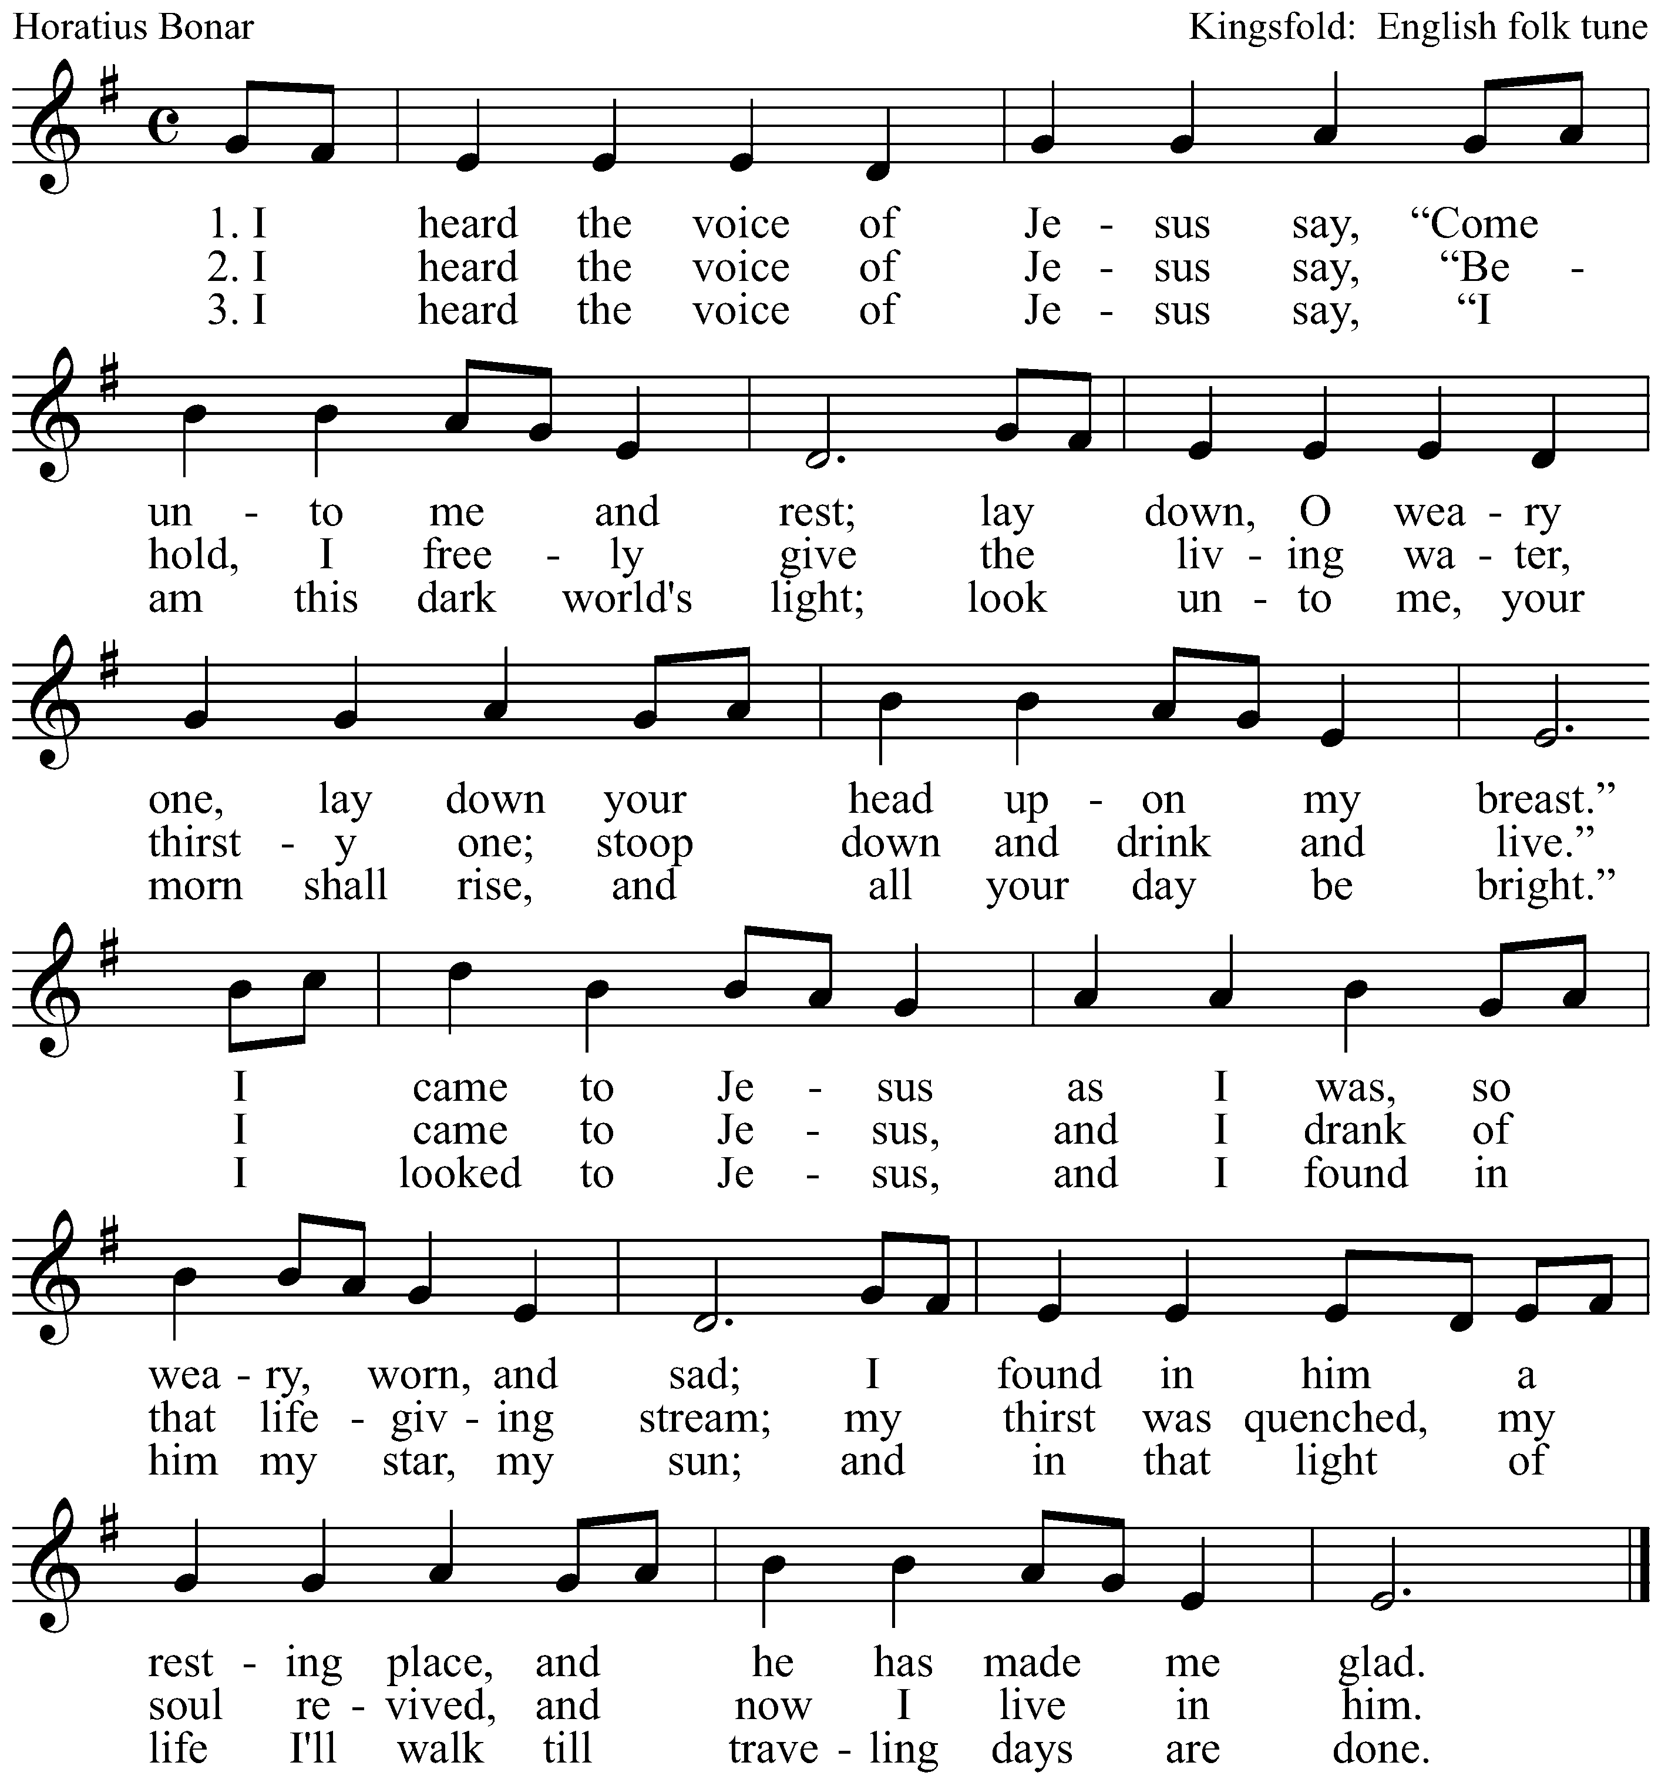

The Apostles’ Creed

I believe in God, the Father almighty,
creator of heaven and earth.

I believe in Jesus Christ, his only Son, our Lord.
He was conceived by the power of the Holy Spirit and born of the virgin Mary.

He suffered under Pontius Pilate, was crucified, died, and was buried.
He descended into hell.
On the third day he rose again.
He ascended into heaven and is seated at the right hand of the Father.
He will come again to judge the living and the dead.

I believe in the Holy Spirit, the holy catholic Church, the communion of saints,
the forgiveness of sins, the resurrection of the body, and the life everlasting. Amen

Prayers

Let us pray:

God, whose yoke is easy and whose burden is light,
We bring before you millions of people who suffer due to war, ethnic conflict, religious confrontations, intolerance of all kinds, and shortage – either of food, water, housing, education, justice or peace.

Lighten up our burdens, ease our yokes.

Give us courage to denounce mistakes and injustices practiced by our governments, but give us even more courage to face our own incapacity to commit ourselves to actions and attitudes ensuring equity amongst us.

Lighten up our burdens, ease our yokes.

Free us from the heaviness we place on our own shoulders and from the moorings to which we tie ourselves.. Free us to take responsibility over the processes liberating our lives as individuals and as humanity.

Lighten up our burdens, ease our yokes.

We pray for our families, for our Parish, for those who are sick…

Lighten up our burdens, ease our yokes.

Shape us into the shape of peace. Rescue us from a culture propagating hate. Let nobody be left in the corner of life. Let us learn from Jesus, who is gentle and humble in heart and who taught us to pray saying:

Our Father

Our Father in heaven
hallowed be your name,
your Kingdom come,
your will be done,
on earth as in heaven.
Forgive our sins
as we forgive those
who sin against us.
Save us from the time of trial
And deliver us from evil.
For the kingdom, the power,
and the glory are yours,
now and forever. Amen

Benediction

Bless us God who enables us to magnificent counterattacks,
Bless us Christ, who frees us for living humbly and gently,
Bless us the Spirit, who transforms our burdens and yokes into lightness.

Song: Nzamuranza

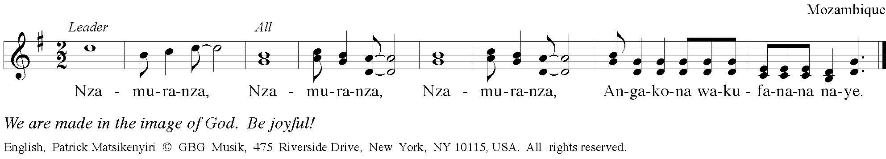

Postlude

Liturgy written by Pastor Lusmarina Campos Garcia, Evangelical Church of Lutheran Confession in Brazil.

