Prelude

Words of Welcome

Welcome to this worship service that, in the context of the World Cup in Brazil, we celebrate in the name of God, Father and Mother of all peoples, in the name of the Son, whose words do not come back empty, in the name of the Spirit, whose seeding is forever. Amen.

The theme chosen for this Sunday comes from Psalm chapter 65 verse 5b: “you are the hope of all the ends of the earth and of the farthest seas”.

Greeting

Seeding time is near.
What will we sow?
Good, creative and stimulating words?
Or dissonance?
We want to sow hope, a glimpse of the future, abundance!
We want to sow gentleness and words of forgiveness.
We want to sow willingness to live with integrity
Even when daily experience insists on saying no!
As the goal of life, we affirm that the result is to be positive,
because the field is fertile for skilled dribbling and repeated sowing.
Therefore our voices rise to scream and to announce
Words pregnant with beauty and uttered with joy.

Song: As rain from the clouds

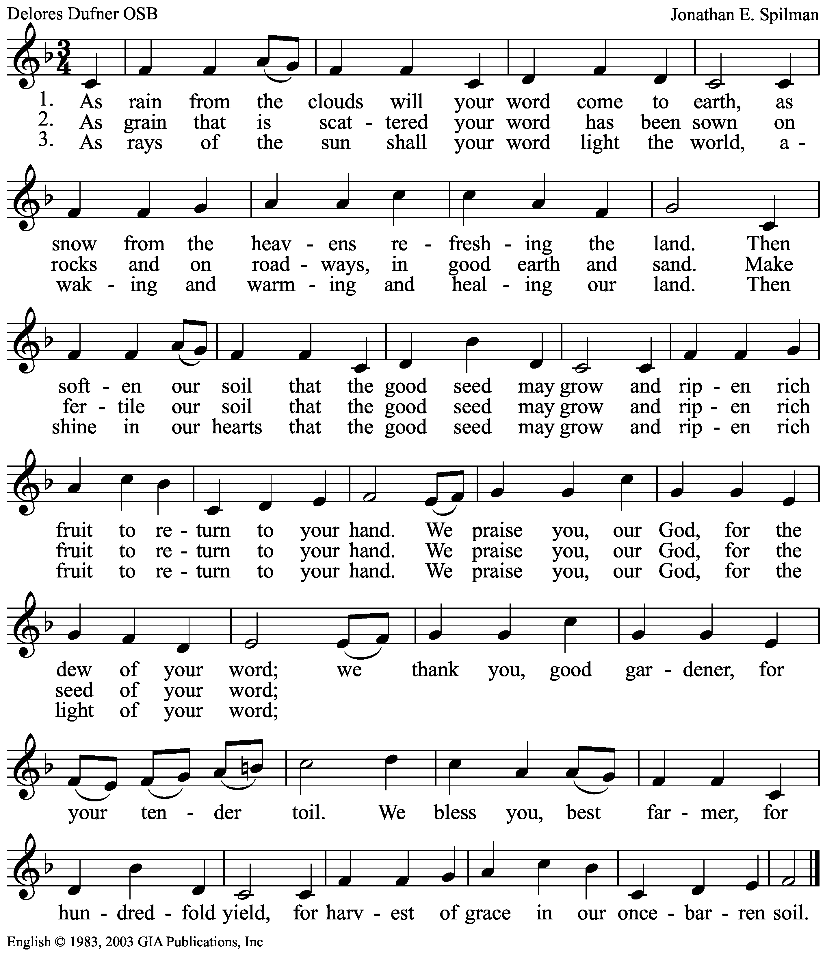

Confession of Sins

Call to Confession:

Empty words, with no strength to communicate, words repeated again and again, carrying no meaning and irrelevant to our inner spirit...
Aren´t our words like that sometimes?
We confess before God emptiness of our words.

Let us pray:

God, whose words create life,
We confess before you how hollow our words can become.
When what we say it is harmful, ineffective, meaningless, forgive us.
When the way we speak excludes, segregates, abandons, forgive us.
When our language is masculinized and we do not notice, forgive us.
When our concepts produce discrimination, forgive us.
When our teachings induce intolerance, forgive us.
When we unlearn words of happiness and tenderness, forgive us.
When our speaking doesn´t bring about closeness, forgive us.

Song: Nos presentamos

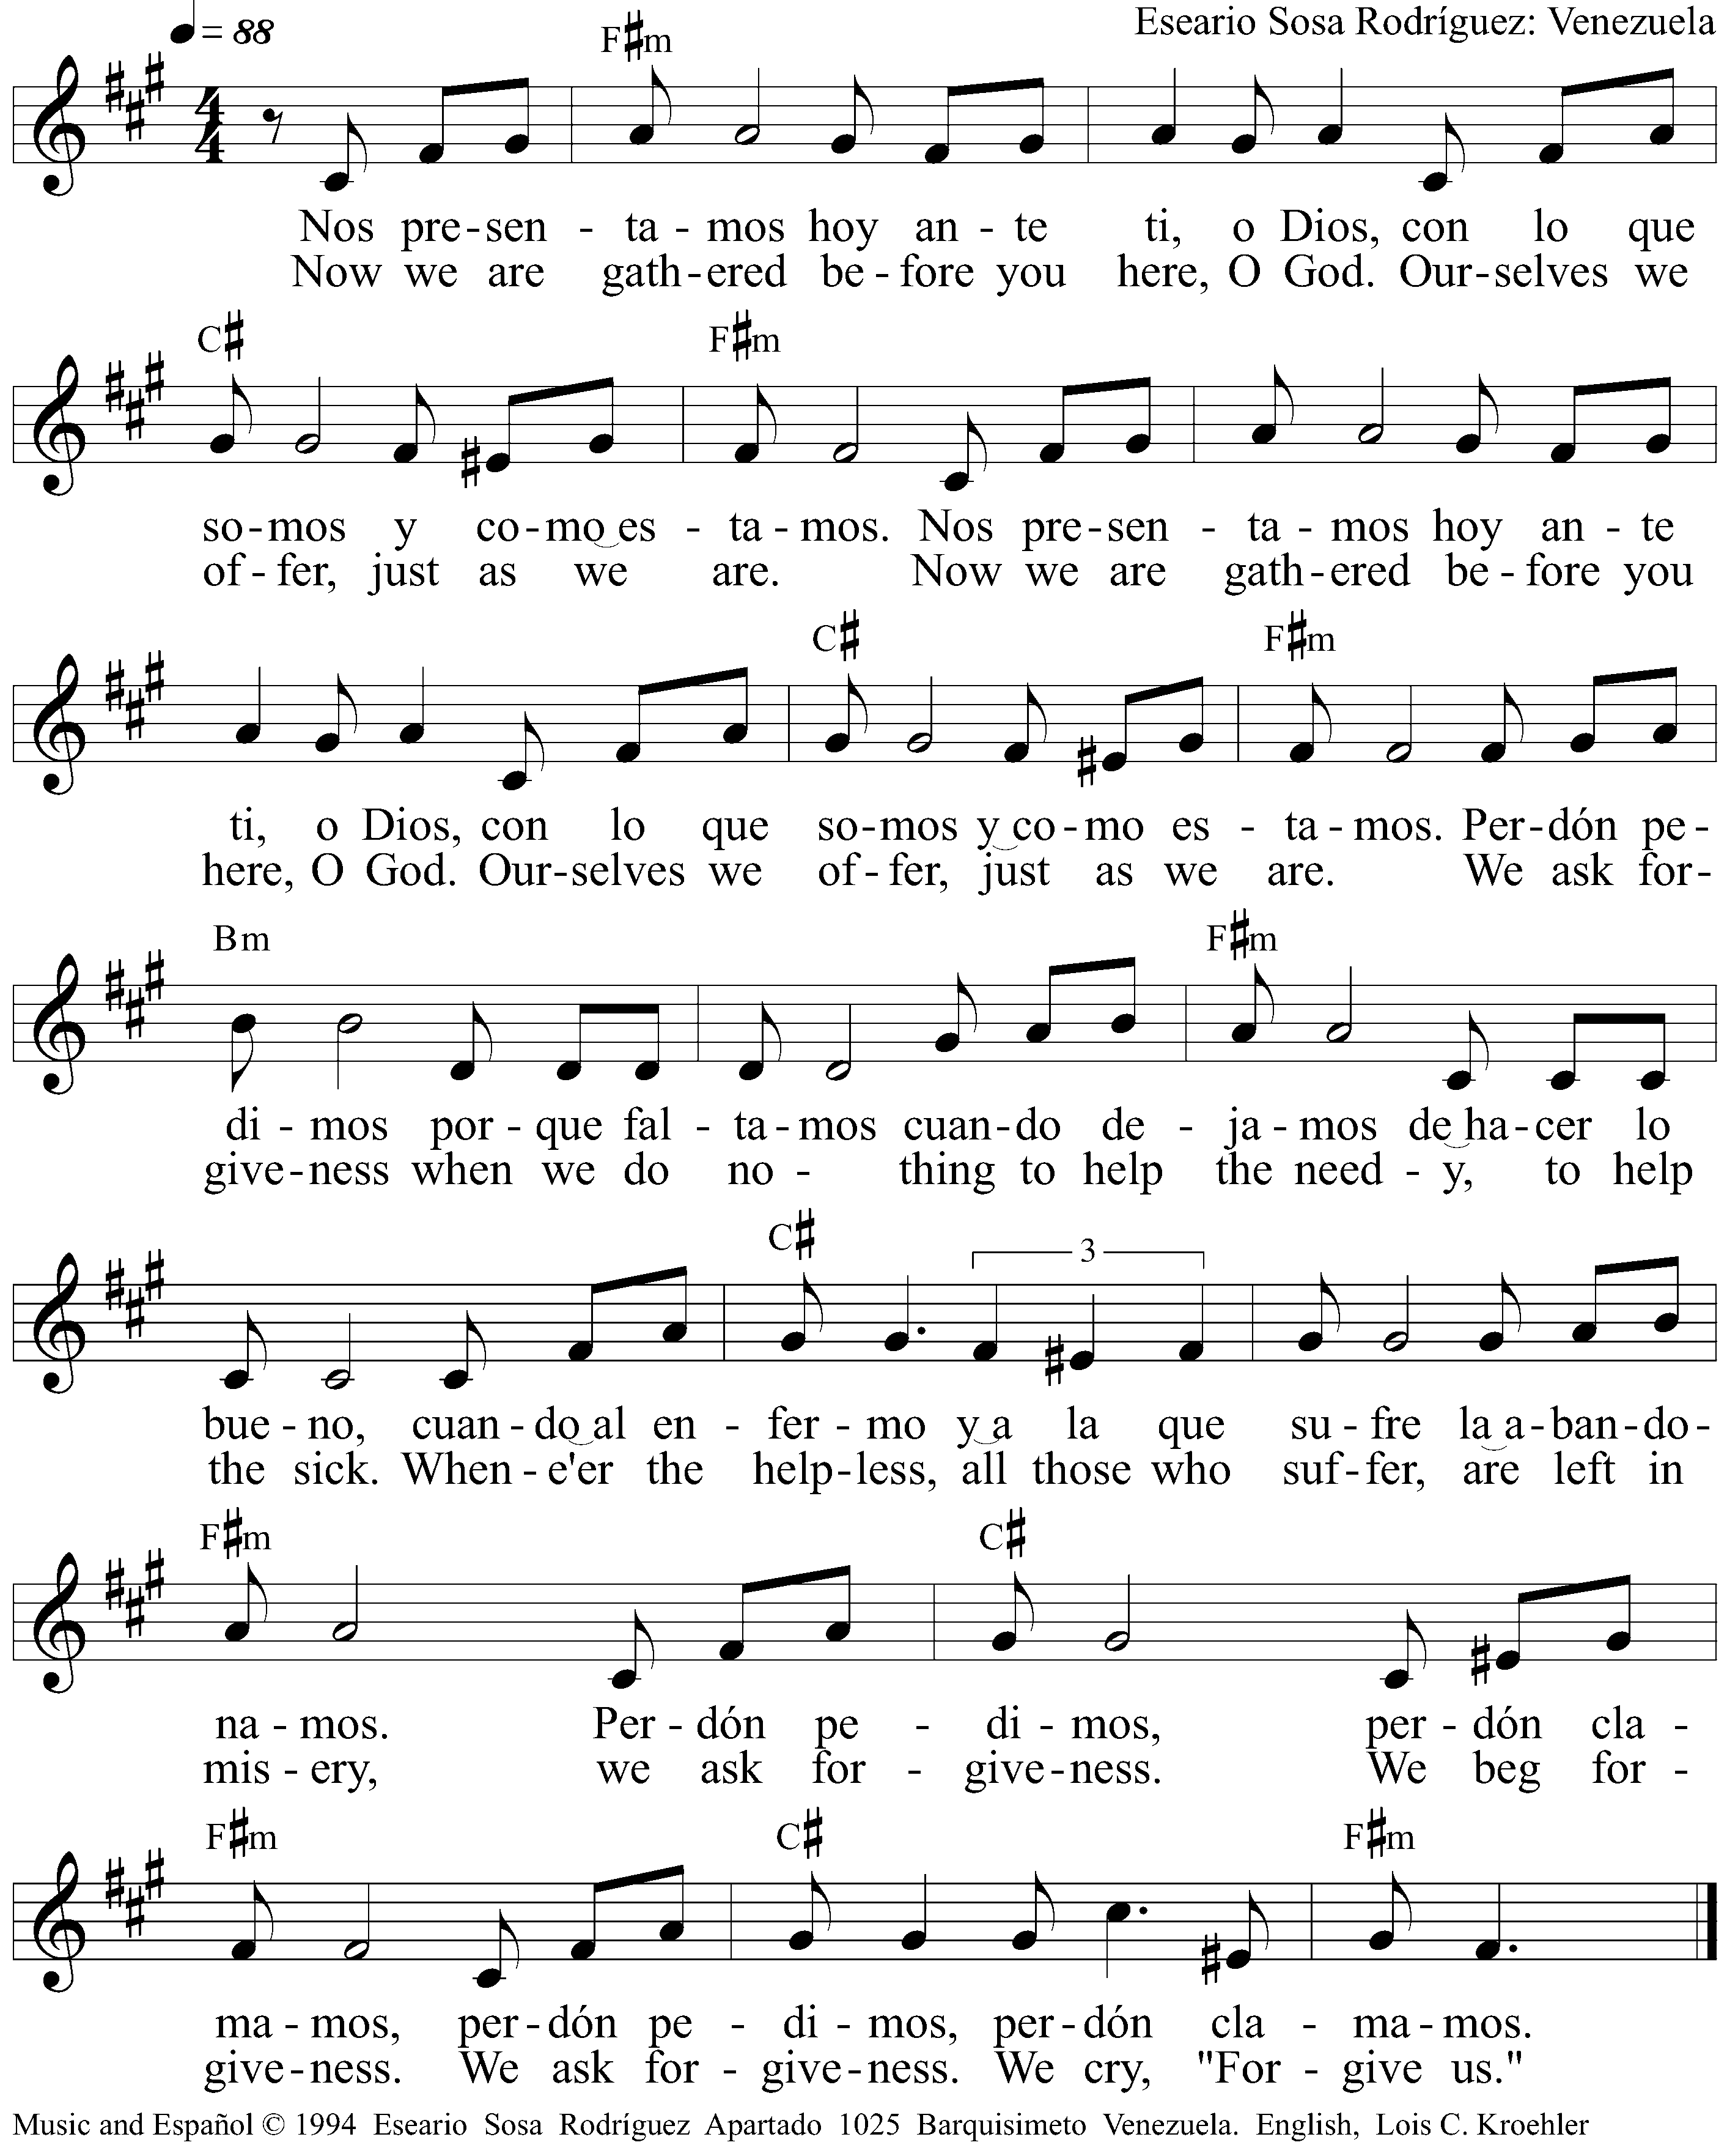

Proclamation of forgiveness of sins

“Praise is due to you, O God, in Zion;
and to you shall vows be performed,
O you who answer prayer!
To you all flesh shall come.
When deeds of iniquity overwhelm us,
you forgive our transgressions…
By awesome deeds you answer us with deliverance,
O God of our salvation.” Psalm 65:1-3 and 5a
Sisters and brothers, in Christ our speaking is imbued with new meaning and our words carry the strength of life.
Song: Gloria a Dios
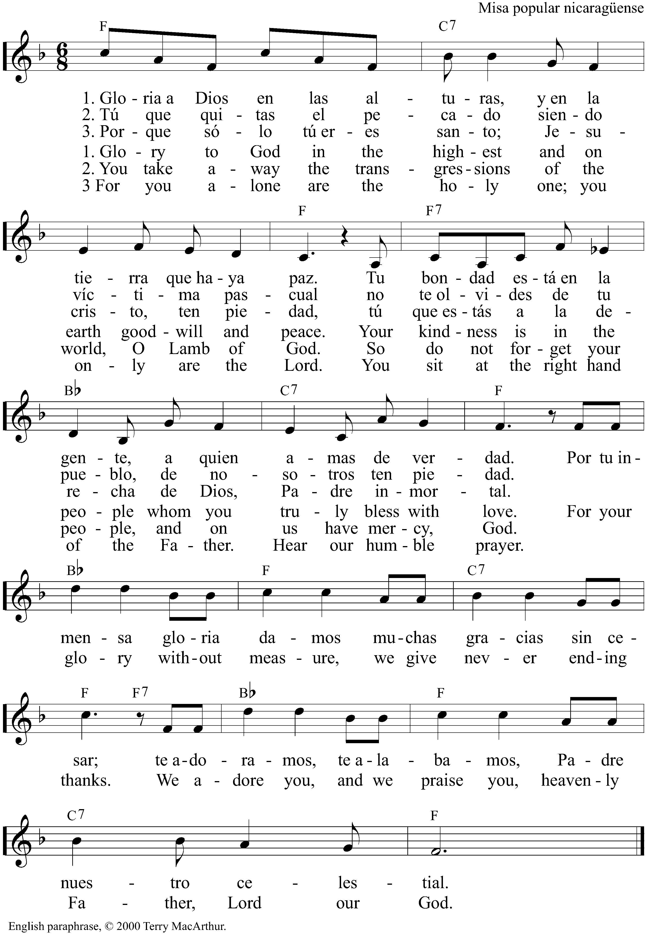
Prayer of the Day
The Lord be with you.
And also with you.

Let us pray:
God, sower of unexpected fields,
Reaper of lush plantings,
We offer ourselves to be the field
in which your word falls and bears fruit.
As the Maracanã, with its soft green grass waits for the players,
we wait for you.
As its bleachers are dressed in blue, yellow and white,
we are dressed up by hope in your sowing.
Just as the eyes of the world are fixed on the scoreboard at the end of each match,
we set our eyes on your mercy.
Grant that, filled by your Word, we risk more intricate moves,
and permeated with your love, we bear the possibility of plentiful harvests.
In the name of the Word made flesh. Amen

Liturgy of the Word

Old Testament Reading Isaiah 55:10-13

“For as the rain and the snow come down from heaven,
and do not return there until they have watered the earth,
making it bring forth and sprout,
giving seed to the sower and bread to the eater,
so shall my word be that goes out from my mouth;
it shall not return to me empty,
but it shall accomplish that which I purpose,
and succeed in the thing for which I sent it. For you shall go out in joy,
and be led back in peace;
the mountains and the hills before you
shall burst into song,
and all the trees of the field shall clap their hands. Instead of the thorn shall come up the cypress;
instead of the brier shall come up the myrtle;
and it shall be to the Lord for a memorial,
for an everlasting sign that shall not be cut off.”
Song: Aleluia
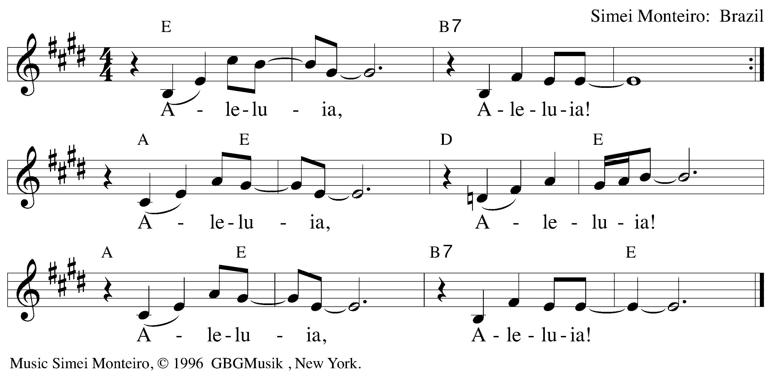
Gospel Reading Matthew 13:1-9

That same day Jesus went out of the house and sat beside the lake. Such great crowds gathered around him that he got into a boat and sat there, while the whole crowd stood on the beach. And he told them many things in parables, saying: ‘Listen! A sower went out to sow. And as he sowed, some seeds fell on the path, and the birds came and ate them up. Other seeds fell on rocky ground, where they did not have much soil, and they sprang up quickly, since they had no depth of soil. But when the sun rose, they were scorched; and since they had no root, they withered away. Other seeds fell among thorns, and the thorns grew up and choked them. Other seeds fell on good soil and brought forth grain, some a hundredfold, some sixty, some thirty. Let anyone with ears* listen!’

Sermon

Song: Almighty God, your Word is cast
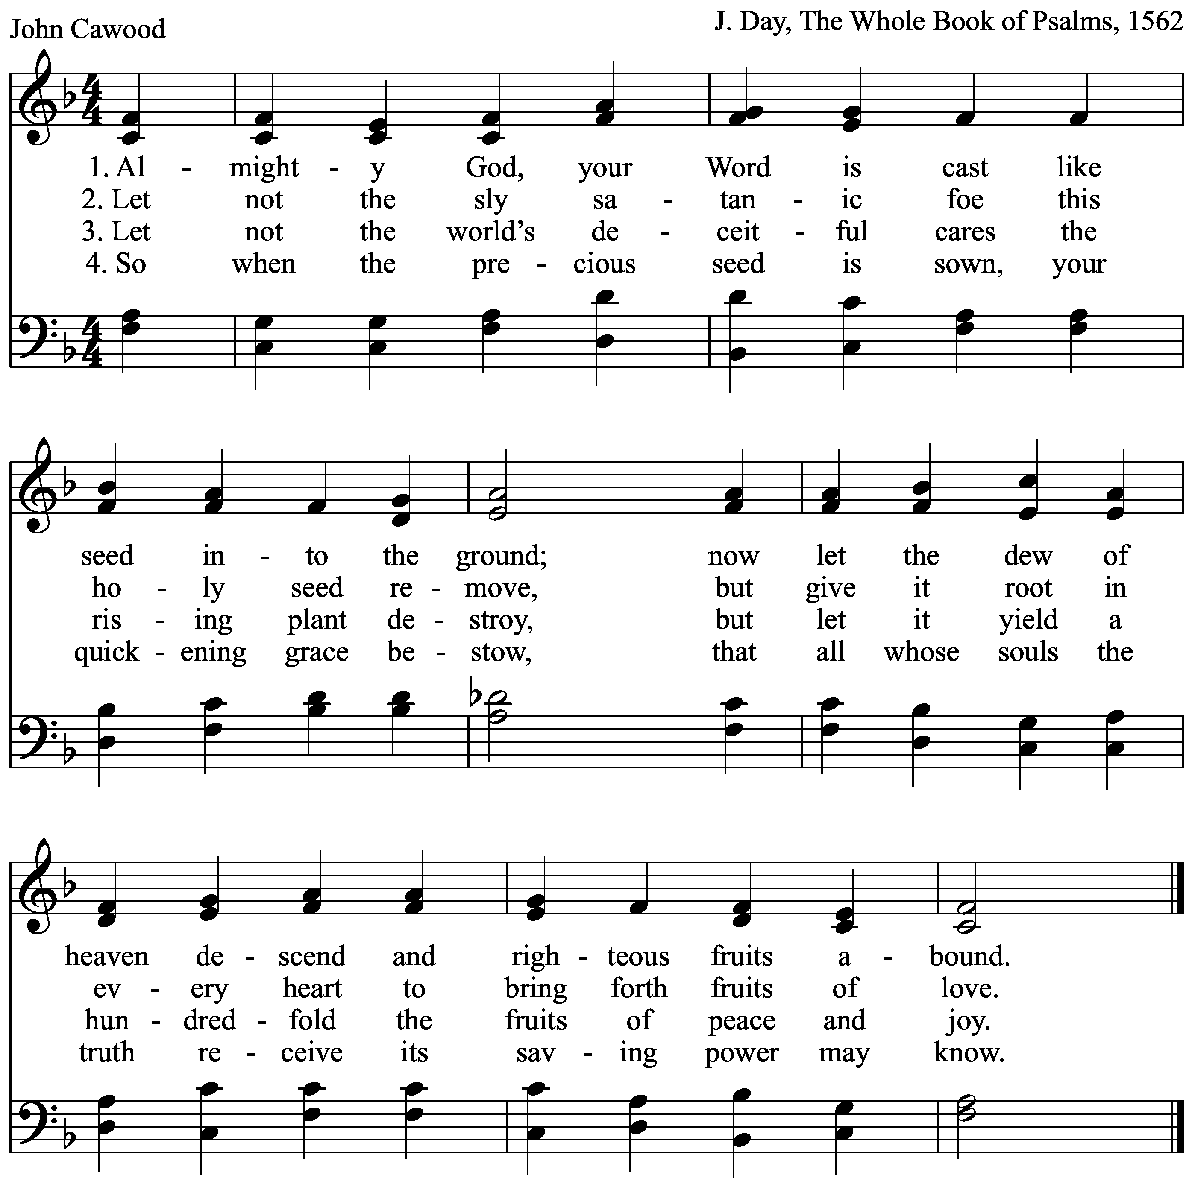
The Apostles’ Creed

I believe in God, the Father almighty,
creator of heaven and earth.

I believe in Jesus Christ, his only Son, our Lord.
He was conceived by the power of the Holy Spirit and born of the virgin Mary.

He suffered under Pontius Pilate, was crucified, died, and was buried.
He descended into hell.
On the third day he rose again.
He ascended into heaven and is seated at the right hand of the Father.
He will come again to judge the living and the dead.

I believe in the Holy Spirit, the holy catholic Church, the communion of saints,
the forgiveness of sins, the resurrection of the body, and the life everlasting. Amen

Prayers

Let us pray:

God, sower of unexpected fields, reaper of lush plantings, we bring before you billions of people around the planet who are watching the World Cup games. Bless us all. May the spirit of sports inhabit us in a way that, where there is war or conflict, truce takes over; where there is sadness, joy takes over; where there is gloom, celebration takes over.

May your fields be filled with peace.

Thousands of tongues share a common vocabulary around the world in this World Cup month, using football words such as: field, player, referee, corner kick, yellow card, red card, score, preventing, big area, barrier, kicking, ball, dribbling, goal. These words sow joy in the places where they are spoken.

May your fields be filled with peace.

Other vocabulary is also needed to expose what is still missing: inclusive urban housing planning; fair treatment of those who face homelessness due to construction of public projects; justice for traditional populations - indigenous and maroon; investments in health and education. May these words sow political willingness and citizen awareness in the places where they are heard.

May your fields be filled with peace.

We pray for ourselves, for our families, for our parish and community, for those who are ill… The community is now invited to name those we carry in our hearts.

May your fields be filled with peace.

Make of us sowers of hope and reapers of joy. Inspire us to speak words of life instead of emptiness; help us to speak words that nourish the process of new possibilities and alternatives.

May your fields be filled with peace.

We pray in the name of Jesus Christ, who taught us:

Our Father

Our Father in heaven
hallowed be your name,
your Kingdom come,
your will be done,
on earth as in heaven.
Forgive our sins
as we forgive those
who sin against us.
Save us from the time of trial
And deliver us from evil.
For the kingdom, the power,
and the glory are yours,
now and forever. Amen

Benediction

Bless us God who, of the many words spoken about him, prefers those that bring about life;
Bless us Christ, word made ​​flesh, experience, encounter, immensity;
Bless us Spirit, blowing wind transforming word into song.

Song: La Palabra del Señor

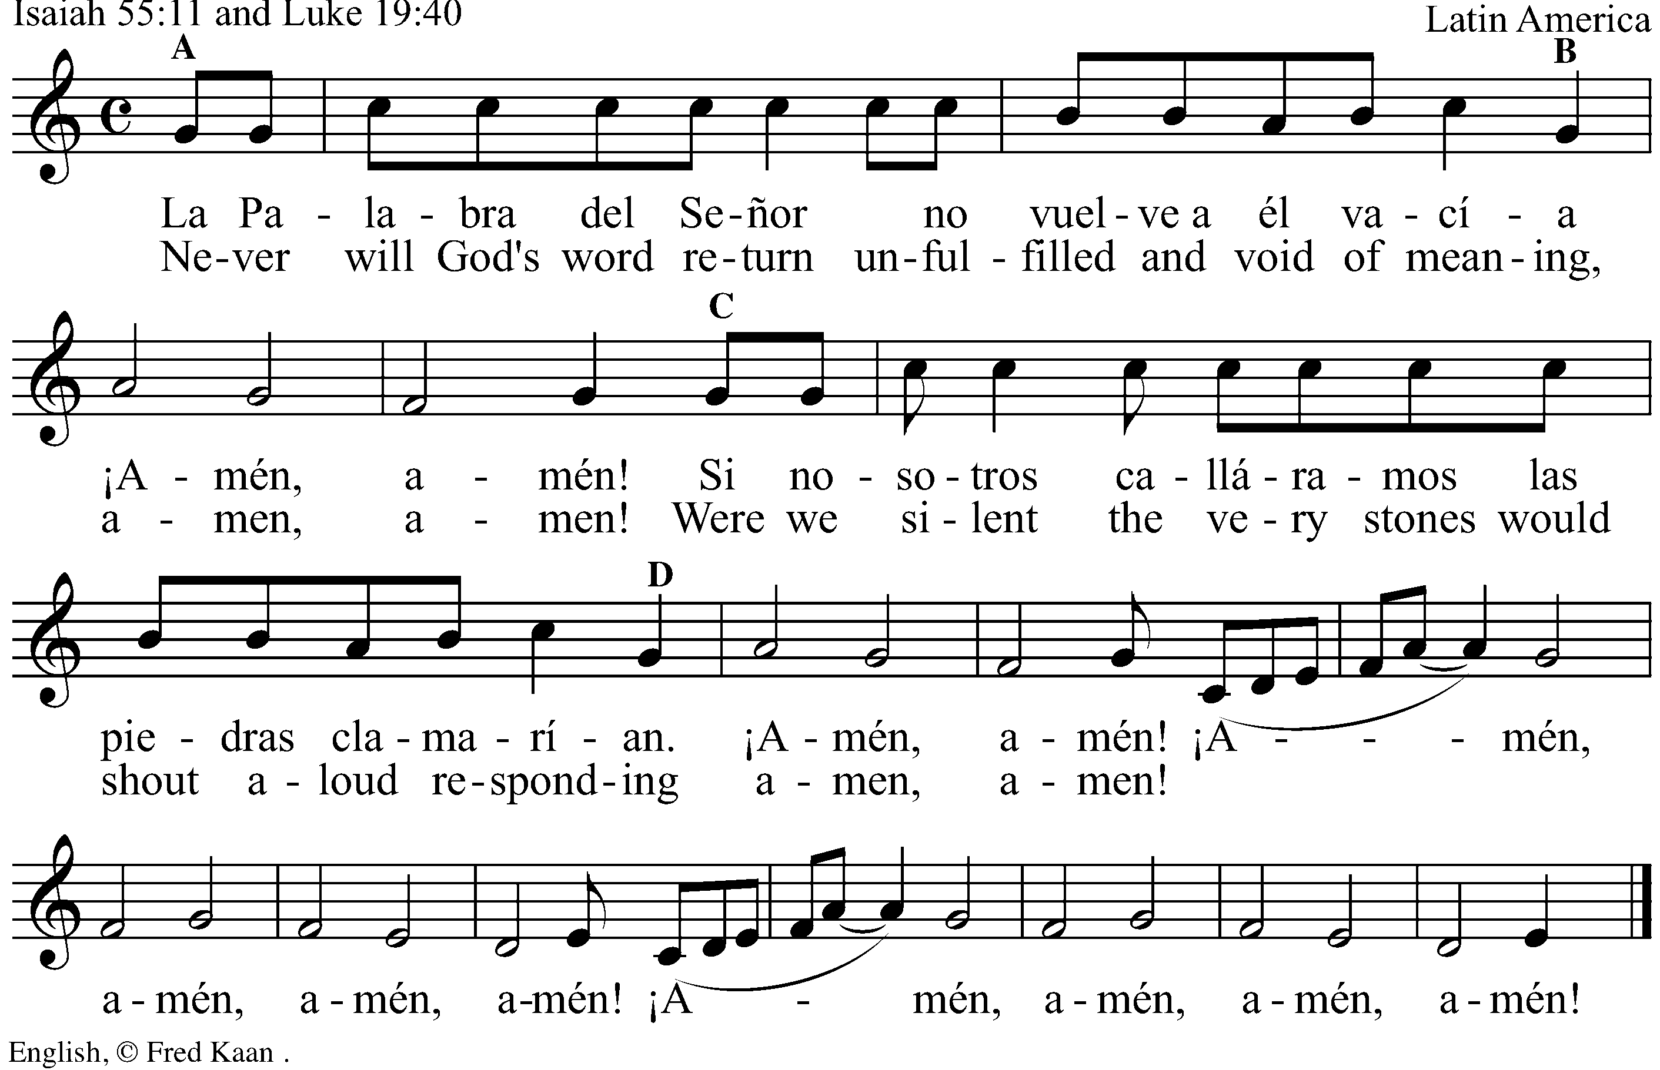

Postlude

Liturgy written by Pastor Lusmarina Campos Garcia, Evangelical Church of Lutheran Confession in Brazil.

