The World Cup in Brazil, 2014 – Worship Service 1

This liturgy doesn’t contain Eucharist

Songs are suggested in the liturgy, however they may be replaced by other songs that are better known by local communities. There are two songs that were composed specifically for the World Cup period: Kyrie and Alleluia.

At this liturgy, the words in bold and italics are said by the whole community.

Prelude

Words of Welcome

Welcome to this worship service that, in the context of the World Cup in Brazil, we celebrate in the name of God, Father and Mother of excellent moves, in the name of the Son, who makes life vibrate and in name of the Spirit, who surprises by unexpected strategies. Amen.

The theme chosen for this Sunday comes from Isaiah chapter 55 verse 12: "You will come out with joy and be led in peace. In your presence, hills and mountains explode with joy, all the trees will clap their hands. "

Greeting

Trees clapping their hands, hills and mountains bursting with joy,
Crowds loose in the streets, in stadiums and parks,
on pace to feast and revelry!
Life does not wait quietly - it projects, anticipates, and recreates itself,
in a continuous movement of possibilities granted or invented;
sometimes disjointed, sometimes harmonious.
This strength in the overlapping fibers of existence
is for us dazzle, impulse, propulsion,
in praise of God, lover of feasts and crowds,
who sings beside us and vibrates
in motion running to score
that which is integrity, justice and life.

Song: Gracias, muchas gracias - Rafael Zamorra (Thuma Mina 145)

Thanks, always thanks, always thanks to you, my Lord!
Thanks, always thanks, always thanks to you, my Lord!
With all our laughter and all of our song
With all our struggle and sorrow
Ourselves we offer.
To you we belong.
Your word brings hope for the morrow.
Longing fro life which comes only from you,
We wait the strength for tomorrow.
Taking what we give, you make something new for all people,
All our sisters and friends.

Confession of Sins

Call to Confession:

Moves are many,
intentions also,
different interests are at play
while life flows on in the comings and goings of expectations, politics,
slander or not,
Brazilians from opposing teams: those proud to receive the World Cup, and those who believe it is an extravagance.
The World Cup is more than the World Cup; it is a symbol. On one hand, the most loved sport: soccer, synonymous with celebration and emotions born at the center of the heart;
and on the other hand a rallying flag for those who criticize the government.
But life flows on in the comings and goings of expectations, politics,
slander or not,
Brazilians form opposing teams: those proud to receive the World Cup, and those who believe it is an extravagance

Let us pray:

God of angry and euphoric fans,
we come before you confessing our discomfort.
When we do not play in favor of life, forgive us.
When we feast at the expense of justice, forgive us.
When children and adolescents are sexually abused, forgive us.
When women and men are trafficked, forgive us.
When racism is still a reality in our midst, forgive us.
When we speak maliciously, forgive us.
When we do not work for peace, forgive us.
When our hands unlearn applauding and joy becomes scarce, forgive us.

Song: Kyrie

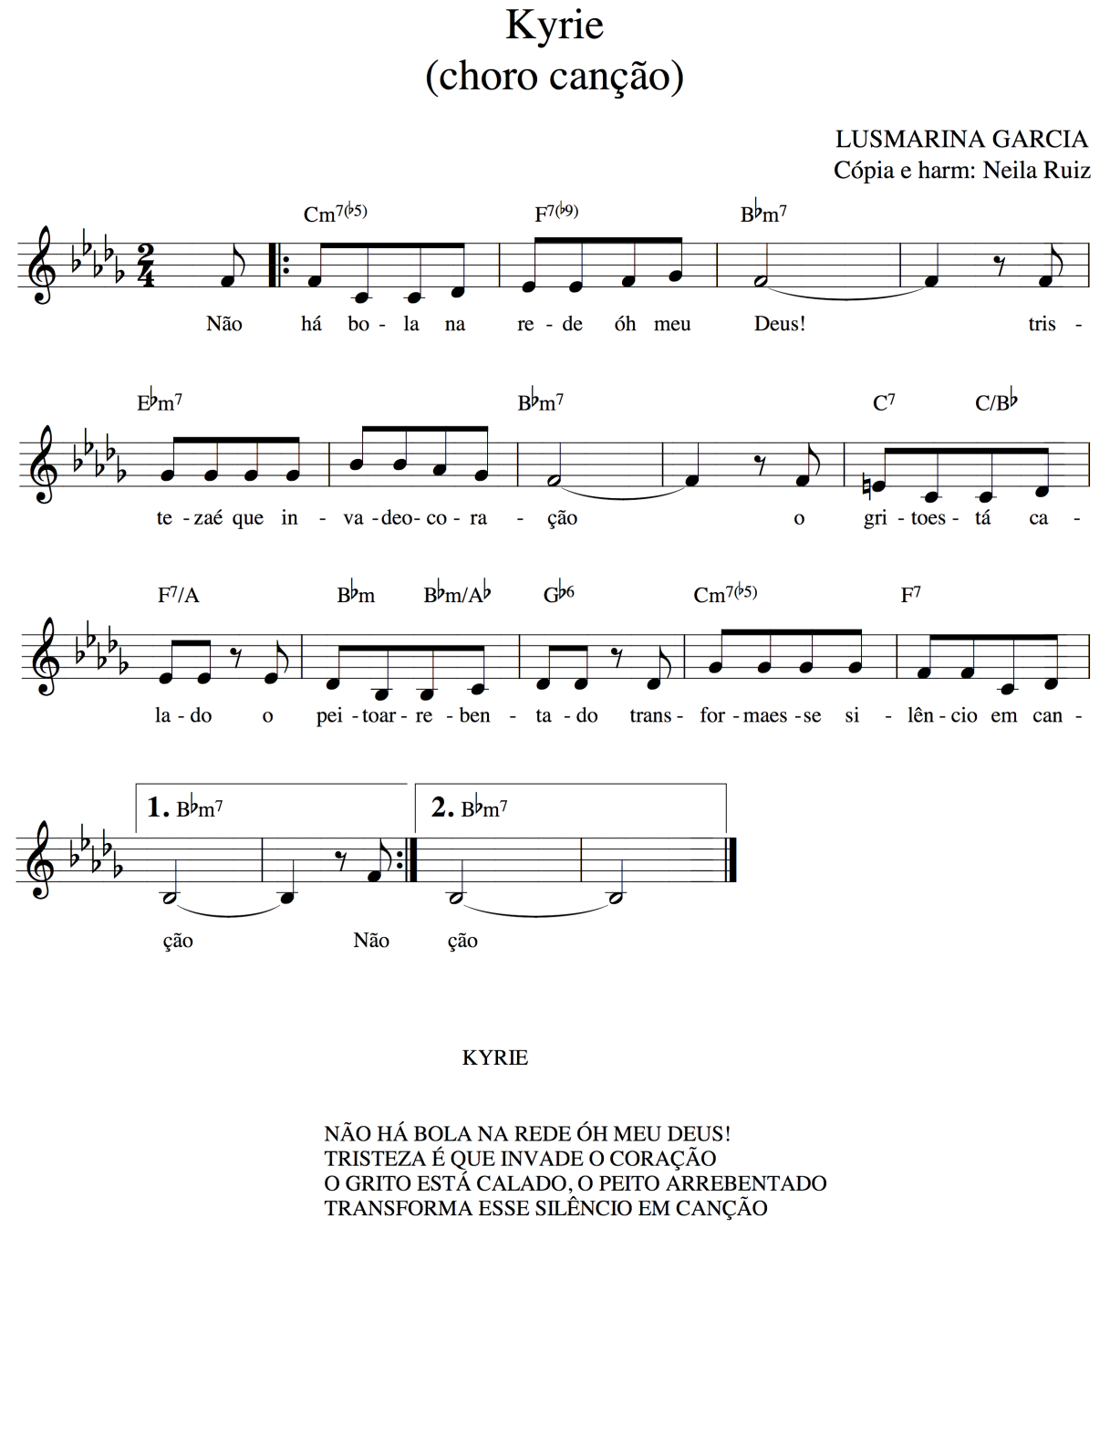

Proclamation of forgiveness of sins
“The righteous flourish like the palm tree, and grow like a cedar in Lebanon. ¹³ They are planted in the house of the Lord; they flourish in the courts of our God. ¹⁴ In old age they still produce fruit; they are always green and full of sap, ¹⁵ showing that the Lord is upright; he is my rock, and there is no unrighteousness in him.”Psalm 92:12-15.

Sisters and brothers, in Christ, our discomfort is repaired and our sins are forgiven.

Song: Glory, glory, glory - Pablo Sosa (Thuma Mina 60)

Prayer of the Day
The Lord be with you.
And also with you.

Let us pray:
God of plays well made ​​and amazing dribbling,
kindle us with the maneuvers of your grace.
May we jump for joy knowing ourselves part of a crowd
that enjoy playing the game of peace and justice,
equity, care and beauty;
a multitude born to love
and to commit to the values ​​of your kingdom.
Amen

Liturgy of the Word

Old Testament Reading Isaiah 40:1-5

Comfort, O comfort my people,
says your God.
Speak tenderly to Jerusalem,
and cry to her
that she has served her term,
that her penalty is paid,
that she has received from the Lord’s hand
double for all her sins.
A voice cries out:
“In the wilderness prepare the way of the Lord,
make straight in the desert a highway for our God.
Every valley shall be lifted up,
and every mountain and hill be made low;
the uneven ground shall become level,
and the rough places a plain.
Then the glory of the Lord shall be revealed, and all people shall see it together,
for the mouth of the Lord has spoken.”

Song
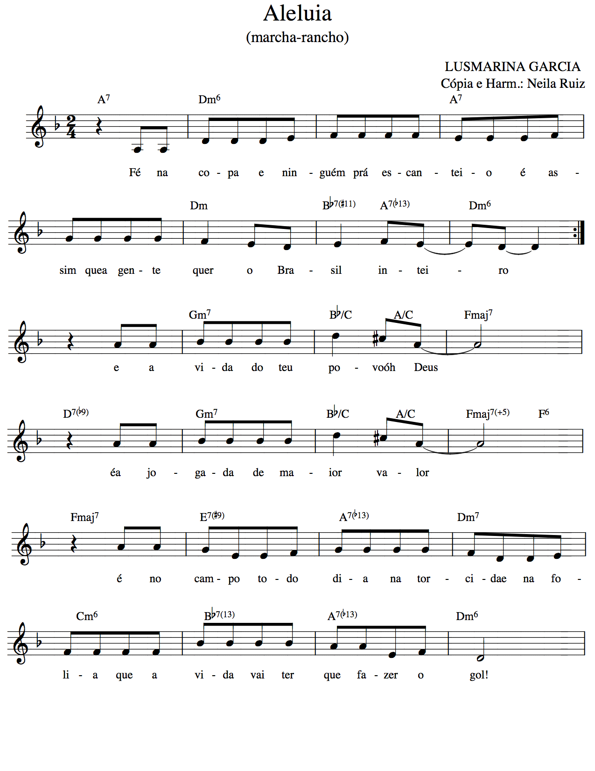

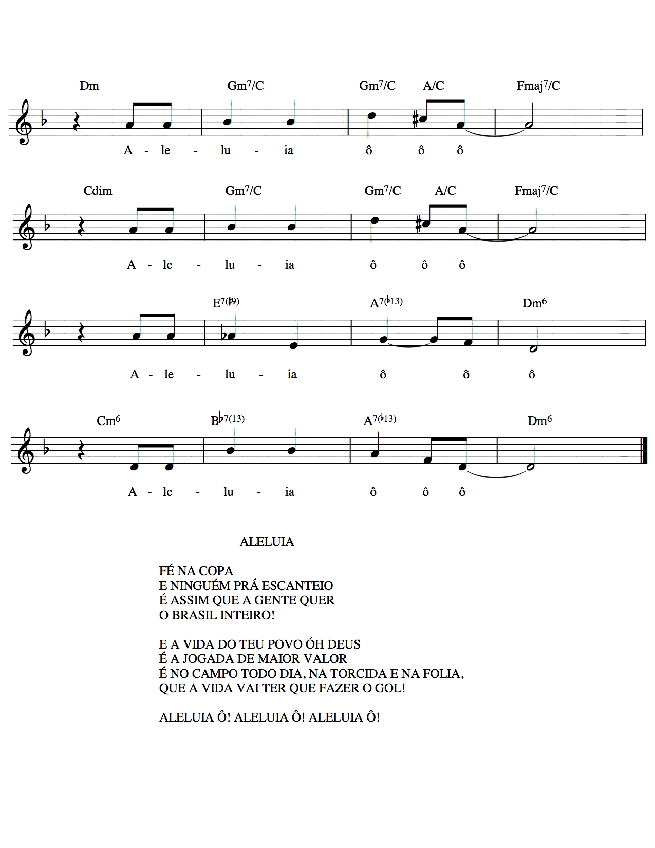
Gospel Reading Matthew 9:35-38

Then Jesus went about all the cities and villages, teaching in their synagogues, and proclaiming the good news of the kingdom, and curing every disease and every sickness. When he saw the crowds, he had compassion for them, because they were harassed and helpless, like sheep without a shepherd. Then he said to his disciples, “The harvest is plentiful, but the laborers are few; therefore ask the Lord of the harvest to send out laborers into his harvest.”

Sermon

Song: Alleluia

The Apostles’ Creed

I believe in God, the Father almighty,
creator of heaven and earth.

I believe in Jesus Christ, his only Son, our Lord.
He was conceived by the power of the Holy Spirit and born of the virgin Mary.

He suffered under Pontius Pilate, was crucified, died, and was buried.
He descended into hell.
On the third day he rose again.
He ascended into heaven and is seated at the right hand of the Father.
He will come again to judge the living and the dead.

I believe in the Holy Spirit, the holy catholic Church, the communion of saints,
the forgiveness of sins, the resurrection of the body, and the life everlasting. Amen

Prayers

Let us pray:

God of plays well made ​​and amazing dribbling,
We bring before you millions of Brazilian people who are receiving the World Cup in their country. Renew in them their vocation to welcome. May there be joy and peace amongst fans, and, if conflicts arise, may they be manageable.

Give Brazil a peaceful World Cup.

We pray for visitors who are travelling throughout the country; that they may feel secure and find friendship from the Brazilian population. May they celebrate like trees that clap their hands.

Give Brazil a peaceful World Cup.

Sexual abuse involving children and teenagers and human trafficking are still realities that need to be eradicated in Brazil and in the whole world. We remember those suffer such cruelties.

Give Brazil a peaceful World Cup.

We pray for ourselves and our families; we remember those who are ill; we remember the poor of the world.

Empower humankind to make moves resulting in peace and justice for the whole of humanity, for, at the end of the day, it is life that has to score.

Give us all a time of peace.

We pray in the name of Jesus Christ, who taught us:

Our Father

Our Father in heaven
hallowed be your name,
your Kingdom come,
your will be done,
on earth as in heaven.
Forgive our sins
as we forgive those
who sin against us.
Save us from the time of trial
And deliver us from evil.
For the kingdom, the power,
and the glory are yours,
now and forever. Amen

Benediction

Bless us God, author of well done plays ​​and skillful dribbling.
Bless us the One who knows how to run and to score in favor of life.
Bless us today and tomorrow with strength and joy
Until our hands learn how to clap like the trees and we explode with joy like the mountains and the hills.
Amen

Song: You shall go out – S. Dauermann (Thuma Mina 176)

You shall go out with joy
And be lead forth with peace
And the mountains and the hills shall break forth before you.
There’ll be shouts of joy and the trees of the field shall clap, shall clap their hands,
And the trees of the field shall clap their hands
And the trees of the field shall clap their hands
And the trees of the field shall clap their hands
And you’ll go out with joy.

Postlude

Liturgy written by Pastor Lusmarina Campos Garcia, Evangelical Church of Lutheran Confession in Brazil.

